ANALYSIS OF MATERIAL SUPPLIER SELECTION FOR PROPERTY DEVELOPMENT COMPANY PT. REXVIN GROUP USING THE METHOD ANALYTICAL HIERARCHY PROCESS
Jumiati¹ and Maryani Septiana²
{ajumi267@gmail.com¹, maryaniseptiana@polibatam.ac.id²}
Politeknik Negeri Batam, Departement of Business Management, Batam City, Indonesia¹²

Abstract: The objective of this article is to present a decision support system for supplier selection of materials for property development companies, specifically PT. Rexvin Group, using the Analytical Hierarchy Process (AHP). The importance of this research is to provide variations in the application of the AHP method in the property industry, thereby enriching the scientific literature related to material procurement. The research begins by identifying the main criteria (price, material quality, and material handling) based on the opinions of expert respondents, then analyzed pairwise to determine the priority weight of each criterion. The next step is to compare supplier alternatives (Katindo Utama, Citra Beton, and Lingga Furnindo) against each criterion to obtain the final score. The calculation results show that Katindo Utama is the best supplier with the highest score (0.632), followed by Citra Beton (0.232) and Lingga Furnindo (0.135). These results prove that the AHP method can be a systematic, objective decision-making tool and can serve as a reference for material supplier selection in the property sector.

Keywords: Supplier, Material, AHP, Property, Procurement

Introduction

As time progresses, the property sector, as one of the important sectors in the economy, continues to experience rapid development. Property developers compete in developing innovative designs, construction quality, and cost efficiency to achieve their vision and enhance competitiveness in the market. To provide timely, high-quality, and affordable property products, companies need to strengthen performance by focusing on collaboration, coordination, and synchronization in managing supply chain activities [9]. Supply Chain Management is the process of managing everything from information flow, materials, to services that involves all parties in the company network, suppliers, and customers [11].
In the property development process, the procurement of construction materials becomes a key factor that must be considered. Choosing the right material supplier can help companies improve supply chain performance, avoid delays, and maintain the quality of the construction results [3]. Suppliers themselves are parties that provide goods or services needed by the company for the production and construction process [2]. Therefore, companies need to conduct periodic evaluations and assessments of suppliers to ensure that the selected suppliers meet the established quality, price, and service standards.
PT. Rexvin Group as a property developer in Batam requires a large supply of construction materials with consistent quality and high delivery accuracy. Challenges in material procurement often arise, such as delivery delays, material quality mismatches with company standards, and price fluctuations that can affect project costs. This situation highlights the importance of supplier performance evaluation while considering various strategic criteria.
To assist in the systematic process of evaluating and selecting material suppliers, this research uses the Analytical Hierarchy Process (AHP) developed [5]. AHP allows company break down the supplier selection problem into a hierarchical structure, compare criteria in pairs, and calculate the priority weights of each criterion so that decisions can be made more objectively [5] [2]. This research also refers to previous studies that indicate the effectiveness of AHP in material supplier selection across various industries [3].
Using primary criteria such as price, material quality, and material handling, this research aims to help PT. Rexvin Group determine the best material supplier that aligns with the company's priorities. The results of this research are expected to serve as a reference for the company to improve supply chain efficiency and maintain the quality of development for the property projects it manages.

Research Method
This research is a descriptive study with a mixed methods approach, combining qualitative and quantitative data to analyze the selection of material suppliers at PT. Rexvin Group. The research subjects involve internal company personnel with direct experience in the material procurement process, such as the Purchasing Team, Project Manager, and Project Officer. Informant selection was conducted using purposive sampling techniques, aimed at obtaining valid and relevant data according to the research needs [3].
The data collection technique used is in-depth interviews and a paired comparison questionnaire designed using the Analytical Hierarchy Process (AHP). The interview questions were structured based on the 5W+1H guidelines [11]. to delve deeper into information about important criteria in supplier selection, such as price, material quality, and material handling. The qualitative data obtained from these interviews provide a deeper understanding of the company context, while the quantitative data from the AHP questionnaire becomes the basis for calculating the priority weights of the criteria.
The data analysis level is carried out using the Analytical Hierarchy Process (AHP) method developed by [5]. The first step in AHP is to arrange the decision hierarchy structure, starting from the main goal to the criteria and supplier alternatives. Next, the respondent survey results are converted into a paired comparison matrix. The researchers then calculate the priority weights for each criterion and the final scores for each supplier using manual calculations in Excel [2].
The consistency test is conducted through the calculation of the Consistency Ratio (CR) value. The CR ≤ 0,1 value is considered to meet the consistency requirement, according to the standards set by [5].. After obtaining the priority weights, the next step is to multiply the weights by each supplier's score on each criterion, so that the final score is obtained which becomes the basis for selecting the best supplier.
This research refers to previous research that has successfully applied the AHP method for material supplier selection in various sectors [2] [3]. With this approach, it is expected that the material supplier selection process at PT. Rexvin Group can be carried out more systematically, measurable, and in line with the company's strategic needs, thereby supporting the smooth development of the property development project.

The following are the steps of the AHP method:
1. The initial step involves identifying the problem, selecting alternative solutions, and systematically developing the decision-making hierarchy. This decision-making hierarchy is illustrated as follows.
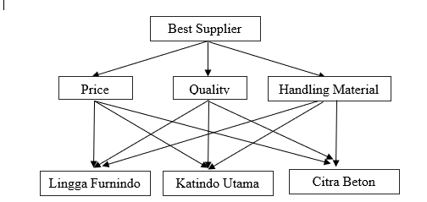
Figure 1. Hierarchical Structure

2. The paired comparison matrix is created to describe the relative contribution or level of influence of each criterion and supplier alternative to the main goal, which is to select the best material supplier for PT. Rexvin Group. This matrix organizes elements such as criteria (price, material quality, and material handling) that are evaluated based on their importance to the goal, as well as supplier alternatives (Katindo Utama, Citra Beton, and Lingga Furnindo) that are compared based on the established criteria. Below is an example of the paired comparison matrix and the paired comparison matrix of alternatives.
Table 1. Example of Pairwise Comparison Matrix of Criteria
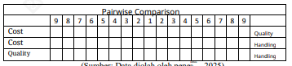
Table 2. Example of Pairwise Comparison Matrix for Criteria Cost
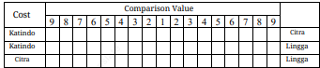
Table 3. Example of Pairwise Comparison Matrix for Quality Criteria
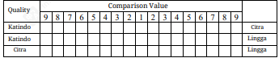
Table 4. Example of Pairwise Comparison Matrix for Handling Material Criteria
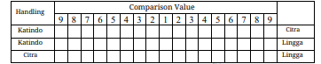
3. The eigenvector of each pairwise comparison matrix is calculated to generate the priority weights for both the criteria and the supplier alternatives. These weights reflect the relative importance of each element within the hierarchy, progressing from the lowest level toward the ultimate objective, namely determining the most suitable material supplier for PT. Rexvin Group.
4. Determine the priority weight of each criterion, by dividing each value a by the number of criteria being compared.
5. Determine the Weight Sum Vector entering the consistency test category. In this case, the initial paired matrix is multiplied by the criterion priority weight.
6. Calculating the CV (Consistency Vector) value The CV value is calculated by dividing the WSV value by the priority weight value. Determining the CV (Consistency Vector) value with the formula. Result and Description
7. Calculating the λ max value or average CF with the formula.
8. Calculating Consistency Index (CI)
9. Calculating Consistency Ratio (CR)

Result and Description
The summary results of the questionnaire distributed to respondents contain many tables. In Table 5 is the summary based on criteria with respondents.
Table 5. Summary Based on Criteria
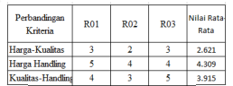
The summary data from Table 5 that has been presented is entered into a paired matrix as shown in Table 6.
Table 6. Paired Matrix of Criteria
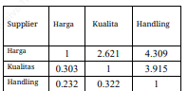
The next step is to calculate the priority weight or eigen vector for each criterion. The priority weight is obtained by calculating the average of the normalized values in each row. This weight will become the basis f or evaluating the level relative importance of each criterion in the selection of material suppliers at PT. RexvinGroup.
After that, the Weight Sum Vector is calculated by multiplying the pairwise comparison matrix with the obtained priority weights. This step is followed by calculating the Consistency Vector, which is obtained by dividing each element of the Weight Sum Vector by the corresponding priority weights as shown in Table 7.
Table 7. Results of alternative level data processing
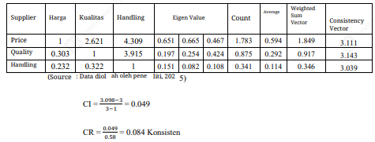
Based on table 7 above, the calculation process in the Analytical Hierarchy Process (AHP) method can be seen, which includes normalizing the paired comparison matrix, calculating the priority weights (eigenvalue), and testing consistency through the Weighted Sum Vector and Consistency Vector.
The calculation results show that the Harga criterion has the highest priority weight with an average value of 0.594, followed by quality with a weight of 0.292, and Handling Material at 0.114. These weight values are obtained from the average eigenvalues of the normalized pairwise comparison matrix. This research indicates that PT. Rexvin Group prioritizes the efficiency of material procurement costs as the primary consideration in supplier selection, while still considering material quality and material distribution smoothness.
Table 8. Summary of Survey on Price Criteria
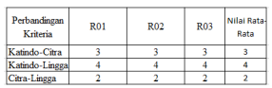
The recapitulation results from Table 8 are entered into the pairwise comparison matrix, which is shown in Table 9 pairwise comparison matrix.
Table 9. Pairwise Matrix for Price Criteria of
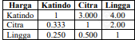
The next step is to calculate the priority weight or eigen vector for each price criterion. The priority weight is obtained by calculating the average of the normalization values in each row.
After that, the Weight Sum Vector is calculated by multiplying the pairwise comparison matrix with the obtained priority weights. This step is followed by calculating the Consistency Vector, which is obtained by dividing each element of the Weight Sum Vector by the corresponding priority weights as shown in Table 10.
Table 10. Result of Processing Data Matrix for Price Criteria
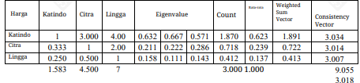
CI = $\frac{3.018​-3​}{3-1​}$ = 0.009
CR = $\frac{0.009}{0.58}$ = 0.016 Konsisten
Table 10 shows the results of processing the pairwise comparison matrix data for the Quality criterion in the supplier evaluation process using the Analytical Hierarchy Process (AHP). I n this table, there are three supplier alternatives, namely Katindo, Citra, and Lingga, which are compared based on respondent perceptions. Based on the Comparison Matrix of Harga, Katindo has a higher relative weight compared to Citra and Lingga, as seen from the average value of 0.623, followed by Citra obtaining an average value of 0.239, and Lingga obtaining the lowest average value of 0.137. This calculation process is then continued by calculating the Consistency Index (CI) and Consistency Ratio (CR) to ensure that the respondents' evaluations of the three suppliers are consistent. Based on the calculation, the obtained CI value is 0.009 and the CR value is 0.016. Since the obtained CR value is smaller than 0.1, it can be concluded that the respondents' evaluations are consistent, and the matrix calculation results can be accepted as a basis for decision-making.
Table 11. Summary of Questionnaire Regarding Quality Criteria
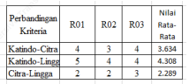
The summary results of the data from Table 11, which has been presented, are entered into a paired matrix as in Table 12
Table 12. Quality Criteria Pairwise Matrix.
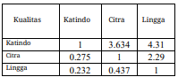
The next step is to calculate the priority weight or eigen vector for each price criterion. The priority weight is obtained by calculating the average of the normalized values in each row.
After that, the Weight Sum Vector is calculated by multiplying the pairwise comparison matrix with the obtained priority weights. This step is followed by calculating the Consistency Vector, which is obtained by dividing each element of the Weight Sum Vector by the corresponding priority weights as shown in Table 13.
Table 13. Results of Processing Pairwise Matrix Data for Quality Criteria
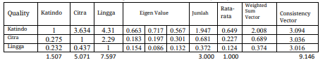
CI = $\frac{3.049​-3​}{3-1​}$ = 0.024
CR = $\frac{0.024}{0.58}$ = 0.042 Konsisten
Table 13 shows the results of processing the pairwise comparison matrix data for the Quality criterion in the supplier evaluation process using the Analytical Hierarchy Process (AHP). I n this table, there are three supplier alternatives, namely Katindo, Citra, and Lingga, which are compared based on respondent perceptions.
Based on the comparison matrix, Katindo has a higher relative weight compared to Citra and Lingga, as seen from the average value of 0.649, followed by Citra obtaining an average value of 0.227, and Lingga obtaining the lowest average value of 0.124.
This calculation process is then continued by calculating the Consistency Index (CI) and Consistency Ratio (CR) to ensure that the responden evaluations of the three suppliers are consistent. Based on the calculation, the CI value obtained is 0.024 and the CR value is 0.042. Since the obtained CR value is smaller than 0.1, it can be concluded that the responden evaluations are consistent, and the matrix calculation results can be accepted as a basis for decision-making.
Table 14. Summary Based on Material Handling
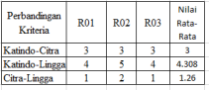
The data summary results from Table 14 that have been presented are entered into a paired matrix as shown in Table 15.
Table 15. Paired Matrix of Handling Criteria
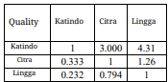
The next step is to calculate the priority weight or eigen vector for each handling criterion. The priority weight is obtained by calculating the average of the normalization values in each row.
Next, the Weight Sum Vector is calculated, which is done by multiplying the paired comparison matrix with the priority weight that has been obtained. This step is followed by calculating the Consistency Vector, which is obtained by dividing each element of the Weight Sum Vector by the corresponding priority weight as shown in Table 15.
Table 16. Results of Processing Pairwise Matrix Data for Handling Material Criteria
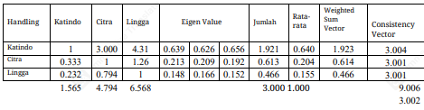
CI = $\frac{3.049​-3​}{3-1​}$ = 0.024
CR = $\frac{0.024}{0.58}$ = 0.042 Konsisten
Table 16 shows the results of processing the pairwise comparison matrix data for the Handling Material criterion in the selection of PT. Rexvin Group suppliers. Based on the normalized matrix results, the highest priority weight was obtained for supplier Katindo with a value of 0.640, followed by Citra with 0.204, and Lingga with 0.155. This indicates that Katindo is considered more superior in terms of material handling and delivery capabilities compared to other suppliers.

Table 17. Final Score of Supplier Alternatives
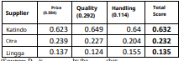
Analysis results with the method Analytical Hierarchy Process (AHP) shows that the price criterion has the highest priority weight of 0.594, followed by quality 0.292 and material handling 0.114. This analysis confirms that PT. Rexvin Group prioritizes cost efficiency as the primary factor in supplier selection, while quality remains an important consideration to maintain project quality.
In the evaluation of three suppliers, Katindo Utama achieved the highest total score of 0.632, followed by Citra Beton 0.232 and Lingga Furnindo 0.135. Katindo Utama's advantage is particularly evident in aspects such as price, quality, and material handling, which align with the company's strategic priorities.
Overall, the AHP method has proven to make the supplier selection process more objective and measurable. These results can serve as a reference for PT. Rexvin Group to evaluate suppliers periodically and can be further developed by adding other criteria as the company's needs evolve in the future.

Conclusion, Suggestion, and Limitations
Based on the research findings, it can be concluded that the selection of material suppliers at PT. Rexvin Group is determined by three main criteria, namely price, quality, and material handling. The evaluation process was carried out using the Analytical Hierarchy Process (AHP) through pairwise comparisons with Saaty’s Scale. The results of the weighting show that price has the highest priority with a value of 0.594, followed by quality at 0.292, and material handling at 0.114.
The analysis of supplier alternatives indicates that Katindo Utama obtained the highest overall score of 0.632, outperforming Citra Beton (0.232) and Lingga Furnindo (0.114). These results suggest that Katindo Utama is the most appropriate choice for fulfilling the company’s material procurement needs. This conclusion emphasizes that price and quality are the dominant factors influencing supplier selection, in line with the company’s strategic priorities in property development projects.

References
[1] Amin, N.F., Garancang, S. and Abunawas, K. (2023), “Konsep Umum Populasi dan Sampel dalam penelitian”, Jurnal Kajian Islam Kontemporer.
[2] Fitriana, N.C. and Santosa, B. (2020), Analisis Faktor-Faktor Pemilihan Suplier Material Pada Jasa Usaha Konstruksi Dengan Metode Fuzzy AHP, Jurnal Fondasi, Vol. 9.
[3] Kaseng, N.S. (2022), Analisis Pemilihan Supplier Bahan Baku Utama Pada Usaha Roti Posarara Bakery Di Kota Palu, Vol. 8.

[4] Kurniawan, C., Sudarwati, W. and Dewiyani, L. (2019), Pemilihan Supplier Part Cover Transmision Case Menggunakan Metode Analitical Hierarcy Process Di PT XHI, Vol. 16.
[5] L. Saaty, T. (2001), “Fundamentals of the Analytic Hierarchy Process”, The Analytic Hierarchy Process in Natural Resource and Environmental Decision Making, pp. 15–35.
[6] Van Laarhoven, P. J. M., & Pedrycz, W. (1983). Fuzzy extension of Saaty’s priority theory. Fuzzy Sets and Systems, 11(1–3), 229–241.
[7] Mwau, F. (2017), Effects of Procurement Planning on Organizational Growth and Development.
[8] Chang, D. Y. (1996). Applications of the extent analysis method on fuzzy AHP. European Journal of Operational Research, 95(3), 649–655.
[9] Sanderson, J., Lonsdale, C., Mannion, R. and Matharu, T. (2015), “Towards a framework for enhancing procurement and supply chain management practice in the NHS: lessons for managers and clinicians from a synthesis of the theoretical and empirical literature”, Health Services and Delivery Research, Vol. 3 No. 18, pp. 1–134, doi: 10.3310/hsdr03180.
[10] Sugiyono. (2013), Metode Penelitian Kuantitatif, Kualitatif, Dan RND, 1st ed., Bandung.

[11] Wardhana, A. (2023), Metode Penelitian Kesehatan.
.

