The Role of Positive Emotions in Mediating the Effect of Price Discounts on Impulse Purchases in GoFood Customers in Batam City

Abstract
Digital transformation in the food delivery industry has changed the consumption patterns of urban communities, especially in purchasing decisions influenced by promotional pricing strategies. Using the Partial Least Square-Structure Equation Model, this study investigated the mediation function of happy emotions in the relationship between discounts and impulse purchasing behavior of GoFood consumers in Batam City. Purposive sampling was used to collect data from 220 respondents using a digital questionnaire. The findings show that discounts significantly affect customers' feelings of happiness and impulse purchases. Positive emotions were shown to increase impulse buying behavior and act as a partial mediator with an indirect effect of 0.366. The structural model shows predictive ability with a determination coefficient of 56.6%. These findings confirm the importance of the emotional dimension in digital food delivery marketing strategies, where price discounts create experiential value that stimulates consumers' spontaneous consumption behaviors.

Keywords:
price discounts, positive emotions, impulse purchases

Introduction
The development of digital technology in the industrial era 4.0 has fundamentally changed people's consumption patterns (Martaleni et al., 2022). Indonesia recorded the highest position in Southeast Asia in the use of food delivery services with gross merchandise value reached 4.6 billion USD in 2023, an increase of 5% from the previous period. Gojek through services GoFood accounting for 38% of the total value, making it the dominant platform that influences the consumption dynamics of urban communities.
In the ecosystem Food Delivery Services, price discounts are a crucial marketing strategy to increase transaction volume. A discount is a discount offered by a seller with the aim of increasing product sales (Lastiur Purba et al., 2022) . This strategy not only provides financial benefits, but also triggers a psychological response of consumers. Positive emotions, which include feelings of pleasure, satisfaction, and happiness, are affective reactions to certain stimuli (Fachrozie et al., 2021). When consumers experience positive emotions as a result of an attractive offer, those emotional impulses can reinforce purchasing decisions without deep rational consideration.
Impulse buying is characterized as the tendency to buy spontaneously with minimal consideration, which is driven by spontaneity (Verhagen & Van Dolen, 2011). In the context of an application GoFood, ease of navigation, and special offer notification systems are the main triggers of impulsive actions. Consumers who initially do not intend to order may be encouraged to make a purchase after seeing an attractive promotion. (Wulandari, 2020) asserts that ease of access to technology and special offers can influence impulse purchase decisions through positive emotional stimulation.
Previous research has explored the relationship between discounts and impulse purchases in a variety of contexts. Wang et al. (2022) show that price discounts and promotions have an important role in evoking positive emotions that significantly influence impulse buying behavior. Hair et al. (2019) showed the role of positive emotions in mediating the influence of price discounts on impulse purchases in Indomaret consumers, but the study was conducted in the context of offline retail. Larasati and Yasa (2021) examined flash sales and online impulse purchases with emotional mediation, but focused on common e-commerce platforms. Sanaky et al. (2013) examined the effect of discounts on impulse purchases in GoFood Medan, but did not analyze the role of positive emotions as a mediating variable.
The lack of a comprehensive study that explicitly examines the process of positive emotion mediation in the relationship between price reduction and impulse purchase in the context of app-based food delivery, especially in Batam City, shows a research gap. The geographical setting, the object of the research, and the development of the theoretical model in this study, which uses positive emotions as a mediating variable, are all innovative.
The purpose of this study is to examine the relationship between discounts, feelings of pleasure, and impulse purchases among GoFood application users in Batam City. The study mainly examines how rebates affect customers' feelings of pleasure, how rebates affect impulse purchases, and how positive emotions affect impulse purchases. In addition, in the context of app-based food delivery services, this study investigated the function of happy emotions as a mediating variable in the relationship between discounts and impulse buying behavior.
The contribution of this research covers three main aspects. First, theoretically, this study fills a gap in the literature regarding the role of positive emotions as a mediating variable in the context of app-based food delivery services. Second, empirically, this study provides evidence from the locus of Batam City that has not been widely explored. Third, practically, this study provides strategic recommendations for business people and sellers on the GoFood platform in designing promotions that consider the emotional dimension to improve marketing effectiveness and customer experience.

Research Methods
To assess how independent factors affect dependent variables through mediator variables, this study uses causal associative methodology. Quantitative techniques were used to investigate the complex interactions between variables using the Structural Equation Modeling-Partial Least Squares (SEM-PLS) method with SmartPLS 4.0 software.

Variable Operations
This study examines three main variables with specific operational definitions. Price discount (X) is defined as a decrease in the value of food products sold on the GoFood application with the aim of increasing sales volume (Sanaky et al., 2013). Positive emotions (M) are the user's pleasant consequential responses when shopping through the GoFood app, including feelings of pleasure, satisfaction, and enthusiasm. Impulsive Purchase (Y) is defined as the act of buying products through the GoFood application spontaneously with minimal consideration driven by impulses (Goel et al., 2022).
Table 1: Research Variable Measurement Indicators
Variable | Indicators | Source
Discounted Prices | X1: Makes me want to buy in bulk  X2: Anticipates promotions from competitors  X3: Saves money | Supma (2018)
Positive Emotions | M1: Feeling happy  M2: Feeling satisfied  M3: Feeling good  M4: Feeling enthusiastic | Devi & Jatra (2020)
Impulse Purchases | Y1: Spontaneity  Y2: Impulsive impulse intensity  Y3: Stimulus Y4  : Not thinking about consequences | Squirting (2019)

Population and Sample
The population of this study is GoFood users in Batam City with an unknown number. The sample size was determined using the Jacob Cohen formula (Salim, 2019) as follows:

$$n=\frac{L}{f^{2}}+2+u+1$$
1.Jacob Cohen's Equation EquationSource: (Salim, 2019)
Where:
- f² = effect size (set to 0.10 to detect small to medium effects)
- u = number of predictor variables (in this study u = 5)
- n = minimum sample number required
- L = power function obtained from a distribution table with a significance level of 1% and a power of 0.95
Based on the Cohen distribution table with the significance level of α = 0.01, the power (1-β) = 0.95, and u = 5, the value of L = 19.76 was obtained. The substitution of these values into the formula yields:
$$n=\frac{19.76}{0.1}+2+5+1$$
The calculation results show that the minimum sample needed is 203.6 respondents, rounded to 204 respondents.

Sampling Techniques
This study uses purposive sampling, which is a nonprobability technique that selects respondents based on certain criteria. The selection of this technique is based on several considerations. First, the unavailability of a complete sampling frame for GoFood users in Batam City makes the probability technique difficult to implement. Second, this study requires respondents with special characteristics who have experience relevant to the phenomenon being studied. Third, time and cost efficiency in data collection while maintaining information quality.
The inclusion criteria for respondents are: (1) domiciled in Batam City, (2) have used GoFood services at least once in the last six months, and (3) have made transactions by taking advantage of price discounts. This criterion ensures that respondents have actual experience of the variables being studied, so that they can provide valid and reliable responses.
The limitations of purposive sampling techniques need to be acknowledged, especially related to the potential for selection bias because respondents are selected at random. The generalization of the results of the study is limited to populations with similar characteristics. However, for exploratory research that focuses on testing the theoretical relationships between variables, this technique is considered adequate provided that the interpretation of the results is done carefully.
Research Instruments
Google Forms is used to distribute structured questionnaires with a 5-point Likert scale as a study tool. Three constructs were measured by eleven items in the questionnaire: three for discounts, four for positive emotions, and four for impulse purchases. Respondents gave the categories of strongly disagree (1.00-1.80), disagree (1.81-2.60), neutral (2.61-3.40), agree (3.41-4.20), and strongly agree (4.21-5.00).
Examples of report items for each variable: (1) Price discounts: "GoFood price discounts often affect my decision to order food in bulk"; (2) Positive emotions: "I feel happy when I find attractive discounts on GoFood"; (3) Impulse purchases: "I often order food through GoFood without planning due to discounts". The complete questionnaire is presented in Appendix 1.
Data Analysis Techniques
Data analysis using SEM-PLS with SmartPLS 4.0 was chosen because of its advantages in handling complex models with limited samples and data that are not fully distributed normally (Anin et al., 2018). The analysis process consists of two main stages.
Evaluation of External Models
The first stage is the evaluation of the measurement model to assess the quality of the instrument through validity and reliability testing. Convergent validity is evaluated through Loading Factor (minimum value of 0.70) and Average Variance Extracted /AVE (minimum value 0.50). Value Loading Factor shows the contribution of each indicator in explaining its latent construction, whereas AVE measures the proportion of variance that the construct of the indicator can explain (Savitri et al., 2024).
Discriminant validity was assessed through cross-loading analysis and Heterotrait-Monotrait Ratio (HTMT) criteria. Cross-loading analysis compares the correlation of an indicator with its own construct versus another construct; the indicator must have a higher correlation with its own construct. An HTMT value below 0.90 indicates adequate discriminant validity.
Alpha Cronbach and Composite Reliability were used to test the reliability construct, with a minimum threshold of 0.70 (Zhang et al., 2007). Internal consistency between items is measured with Alpha Cronbach, but Composite Reliability offers a more precise assessment as it takes into account the specific weight of the indicator.
The measurement model resulting from the PLS algorithm procedure is visualized in Figure 1, which shows the loading factor value of each indicator against its latent construct as well as the AVE value for each construct.
Figure 1. Measurement Model with Outer Loading
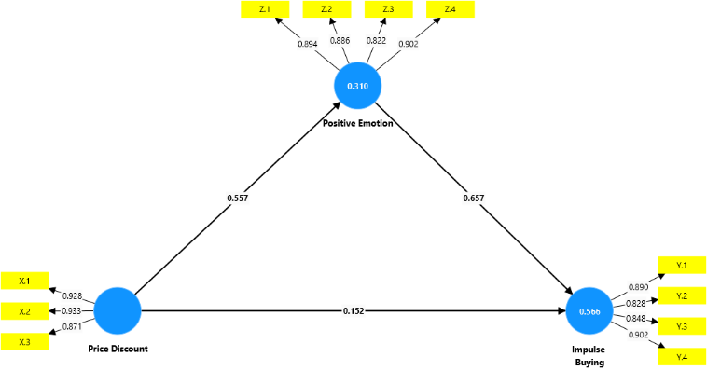
Source: Data processing results with SmartPLS 4.0

Table 2: SmartPLS 4.0 Convergent Validity Test Results Output
 | Price Discount | Impulse Buying | Positive Emotion
X.1 | 0,928
X.2 | 0,933
X.3 | 0,871
Y.1 |  | 0,890
Y.2 |  | 0,828
Y.3 |  | 0,848
Y.4 |  | 0,902
Z.1 |  |  | 0,894
Z.2 |  |  | 0,886
Z.3 |  |  | 0,822
Z.4 |  |  | 0,902
Source: Data processing results with SmartPLS 4.0
The table above shows that all indicators for this study variable are considered valid because the Outer Loading value of each indicator is greater than 0.7. Therefore, questionnaire items can be used for further research.
Table 3: SmartPLS 4.0 Discriminant Validity Test Results Output
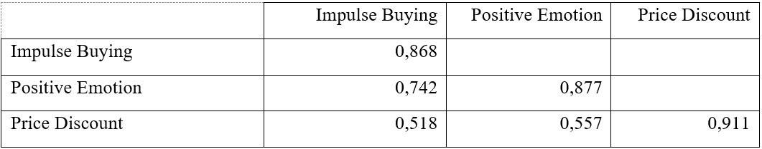
Source: Data processing results with SmartPLS 4.0
As seen in Table 3 above, the correlation between one construct and another construct in the model is less than the square root of the Average Variance Extracted for each construct. This claim shows that the calculated model construct meets the criteria of discriminant validity. Here are the results of Cross Loading.
Table 4: SmartPLS 4.0 Cross Loading Test Results Output
 | Price Discount | Impulse Buying | Positive Emotion
X.1 | 0,928 | 0,503 | 0,546
X.2 | 0,933 | 0,483 | 0,484
X.3 | 0,871 | 0,427 | 0,490
Y.1 | 0,568 | 0,890 | 0,737
Y.2 | 0,409 | 0,828 | 0,638
Y.3 | 0,348 | 0,848 | 0,543
Y.4 | 0,439 | 0,902 | 0,627
Z.1 | 0,526 | 0,649 | 0,894
Z.2 | 0,504 | 0,649 | 0,886
Z.3 | 0,426 | 0,543 | 0,822
Z.4 | 0,492 | 0,742 | 0,902
Source: Data processing results with SmartPLS 4.0
Based on Table 4, each indicator exceeds the threshold of 0.70 and has the highest factor loading value for the construct it is measuring. Thus, it can be said that there is no overlap between the constructs and that each indicator accurately reflects its hidden variables. Thus, based on the cross-loading data, this study model meets the requirements for discriminant validity.
Table 5: HTMT SmartPLS 4.0 Test Result Output
 | Heterotrait-monotrait ratio (HTMT)
Positive Emotion <-> Impulse Buying | 0,814
Price Discount <-> Impulse Buying | 0,567
Price Discount <-> Positive Emotion | 0,617
Source: Data processing results with SmartPLS 4.0
Meanwhile, the value of the Heterotrait-Monotrait Ratio (HTMT) is less than 0.90, as recommended by Hair et al. (2017), which suggests that the threshold of acceptable discriminant validity is also achieved. Each HTMT measurement is less than 0.9.
Table 6: SmartPLS 4.0 Average Variance Extracted (AVE) Test Result Output
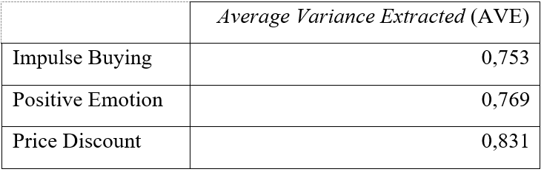
Source: Data processing results with SmartPLS 4.0
Table 6 above shows that the AVE value is more than 0.50, indicating that all indicators have met the requirements and may be reliable for additional testing.

Table 7: Composite Reliability & Cronbach Alpha SmartPLS Test Results Output 4. 0
 | Cronbach's alpha | Composite reliability (rho_a) | Composite reliability (rho_c)
Impulse Buying | 0,891 | 0,902 | 0,924
Positive Emotion | 0,900 | 0,907 | 0,930
Price Discount | 0,898 | 0,903 | 0,936
Source: Data processing results with SmartPLS 4.0
The results of the Composite and Alpha Cronbach tests are good, as shown in Table 7 above. This indicates that all latent variables are reliable because the Composite Reliability and Cronbach Alpha values > 0.70. Thus, it can be said that the research tool, namely questionnaires, is reliable and consistent.
Deep Model Evaluation
To test the relationship between the constructs, the structural model is evaluated in the second step. The percentage of variance in endogenous components that may be caused by external construction is measured by R-squared (R²). The criteria (Abdillah & Hartono, 2015) for interpreting the R2 value were 0.67 (strong), 0.33 (moderate), and 0.19 (weak). The model's better prediction performance is indicated by a higher R2 value.
Using blind techniques, Q-squares (Q²) evaluate the model's overall predictive usefulness. Good predictive ability is indicated by a Q2 value of > 0. The values are interpreted as follows: 0.02-0.15 (weak), 0.15-0.35 (moderate), and > 0.35 (strong), according to Musyaffi et al. (2021). The model's ability to replicate observational data and predict the value of endogenous variables is measured by Q². The direction and intensity of the relationship between latent constructs are measured based on the path coefficient. A significant relationship is indicated by values that are close to +1 or -1 on the coefficient value, which ranges from -1 to +1. The bootstrapping process using 5000 subsamples was used to assess the significance of the path coefficients and produce reliable estimates. The results of the structural model test and the significance of the relationship between variables are presented in Figure 2.

Figure 2. Structural Models with Bootstrapping Test Results
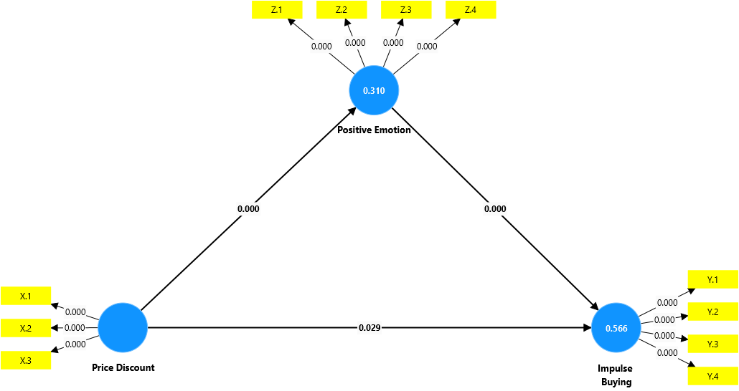
Source: Data processing results with SmartPLS 4.0

Table 8: SmartPLS 4.0 Fit Model Test Output Output
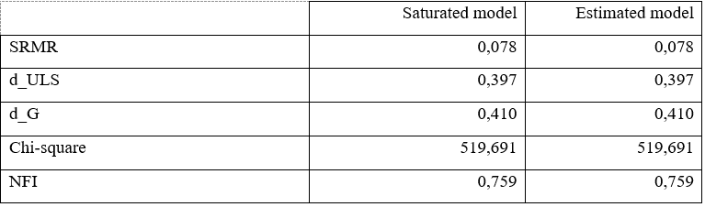
Source: Data processing results with SmartPLS 4.0

The model's Standardized Root Mean Square Residual (SRMR) value, as determined by the test results of the model, is 0.078. It can be concluded that this research model has a reasonable level of suitability because the value is below the known limit, which is 0.080. This shows that the structural model being tested is appropriate because it can reproduce the sample data precisely.

Table 9: Output of R-Square (R2) SmartPLS 4.0 Test Results

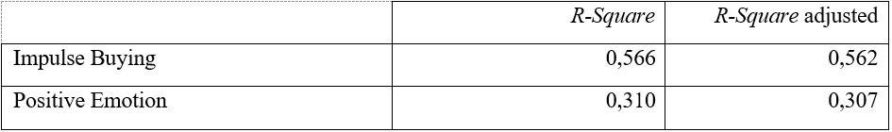
Source: Data processing results with SmartPLS 4.0
- Impulse Buying The R-Square (R2) value for Impulse Buying is 0.566. This means that the Price Discount and Positive Emotion variables combined can explain 56.6% of the variation in Impulse Buying. The strength of this explanation is moderate (moderate). The remaining 43.4% (100% - 56.6%) were influenced by other variables that were not present in this study model.
- Positive Emotion The R-Square (R2) value for Positive Emotion is 0.310. This means that the Price Discount variable is able to explain 31.0% of the variation in Positive Emotion, which indicates a weak to moderate level of explanation. Meanwhile, the remaining 69% (100% - 31.0%) were explained by other factors or variables outside the research model.
Table 10: SmartPLS 4.0 Effect Size (f2) Test Output
 | f-Square
Positive Emotion -> Impulse Buying | 0,685
Price Discount -> Impulse Buying | 0,037
Price Discount -> Positive Emotion | 0,450
Source: Data processing results with SmartPLS 4.0
The f-squared value (f2) indicates the degree of partial influence of each predictor variable on the endogenous variable. The interpretation of this f-square value can be in the form of (Ghozali, 2014):
1) The predictor latent variable is very influential if the f-squared value > 0.35.
2) The latent variable has a moderate influence if the f-squared value is 0.15 ≤ f ≤ 0.35.
3) The latent variable has a weak influence if the f-squared value is 0.02 < f ≤ 0.15.
The following are the results of the f2 value of each exogenous variable against the endogenous variable:
  - The effect of Positive Emotion on Impulse Buying The f-Square value is 0.685. Since this value is greater than 0.35, the influence of Positive Emotion on Impulse Buying is categorized as very strong. This shows that positive emotions are a very important predictor in encouraging impulse buying.
  - The effect of Price Discount on Impulse Buying The f-Square value is 0.037. This value is between 0.02 and 0.15, so the direct influence of Price Discount on Impulse Buying is relatively weak. Although significant, its direct contribution is not as large as the other lines.
  - The effect of Price Discount on Positive Emotion The f-Square value is 0.450. Because this value is greater than 0.35, the influence of Price Discount on Positive Emotion is also very strong. This confirms that giving discounts is a very effective way to evoke positive emotions in consumers.

Table 11: Predictive Relevance Test Results Output Q-Square (Q2) SmartPLS 4.0
 | f-Square
Positive Emotion -> Impulse Buying | 0,685
Price Discount -> Impulse Buying | 0,037
Price Discount -> Positive Emotion | 0,450
Source: Data processing results with SmartPLS 4.0
The structural model of the internal model was evaluated using a predictive relevance score (Q2). If the value of Q-squared is greater than 0 (zero), the model is predictively relevant. The R-squared value for each endogenous variable of the study is shown in the following calculations:
  - Impulse Buying: The value of Q-Square is 0.411. This number is well above 0, which indicates that the model has a good ability to predict Impulse Buying variables. This value can be interpreted as about 41.1% of the variation in Impulse Buying can be explained by the variables that affect it in this model.
  - Positive Emotion: The Q-Square value is 0.234. This value is also greater than 0, which indicates that the model also has predictive relevance for the Positive Emotion variable. This means that about 23.4% of the variation in Positive Emotion can be explained by the model.
Hypothesis Testing
Hypothesis testing is carried out using Bootstrap to evaluate the significance of the relationship between variables. This method generates estimates Standard Errors and Confidence intervals through repeated resampling of the original data (Abaid Ullah Zafar, 2020). The significance level is set at α = 0.05 with a 95% confidence level, meaning that the hypothesis is accepted if p-value < 0.05.
Four hypotheses were explored in the study: H1 (price discount → impulse purchase), H2 (price discount → positive emotions), H3 (positive emotions → impulsive purchases), and H4 (price discounts → impulsive purchases mediated by positive emotions). The calculation of the multiplication coefficient of the X→M and M→Y routes allows the analysis of the indirect effects of mediation. The p-value of the bootstrapping procedure was used to determine the significance of the mediation effect.

Table 12: Predictive Relevance Test Results Output Q-Square (Q2) SmartPLS 4.0
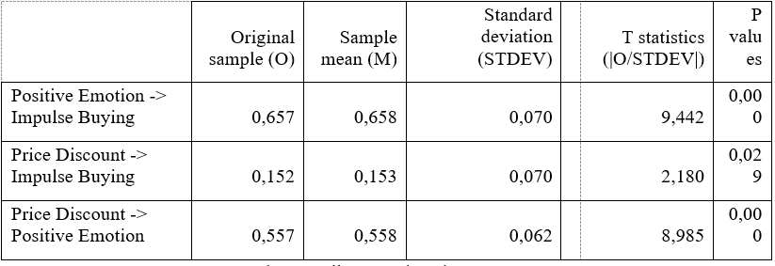
Source: Data processing results with SmartPLS 4.0
In a structural model, the impact of the route should have significant projection value. This relevance can be ascertained through the bootstrapping procedure. Verify the hypothesis application by looking at the significant t-statistical values and parameter coefficients of the bootstrapping procedure report. Verify the significance of the t-table at alpha 0.05 (5%) = 1.96. The t-table and the calculated t-statistics are then compared.
Here are the results of hypothesis testing on structural models:
  - The Effect of Positive Emotion on Impulse Buying The test results show that Positive Emotion has a positive and significant effect on Impulse Buying. A statistical T-value of 9.442 (higher than 1.96), a P-value of 0.000 (less than 0.05), and a path coefficient value of 0.657 all support this. This shows that this theory is approved. In practical terms, this study shows that customers are more likely to make impulse purchases when they feel a happier feeling.
  - The Effect of Price Discount on Impulse Buying The results of the analysis also show that Price Discount has a positive and significant effect on Impulse Buying. This can be seen from the path coefficient value of 0.152, with a T-statistical value of 2.180 (> 1.96) and a P-value of 0.029 (< 0.05). Thus, this hypothesis is accepted. These findings mean that providing price discounts directly and effectively can increase the likelihood of consumers making unplanned or impulsive purchases.
  - The Effect of Price Discount on Positive Emotion The test proved that Price Discount had a positive and significant effect on Positive Emotion. The path coefficient value obtained was 0.557, with a very high T-statistical value of 8.985 (> 1.96) and a P-value of 0.000 (< 0.05). This hypothesis is accepted, which means that price discount strategies have been proven to be successful in creating or increasing positive emotions in consumers.
The following are the results of testing the hypothesis of the indirect influence of X on Y through Z:

Table 13: Output of Predictive Relevance Test Results Q-Square (Q2) SmartPLS 4.0

 | Original sample (O) | Sample mean (M) | Standard deviation (STDEV) | T statistics (|O/STDEV|) | P values
Price Discount -> Positive Emotion -> Impulse Buying | 0,366 | 0,366 | 0,053 | 6,950 | 0,000
Source: Data processing results with SmartPLS 4.0
The results of the hypothesis test show that there is a positive and significant indirect influence of Price Discount on Impulse Buying through Positive Emotion. This finding proves that the Positive Emotion variable has succeeded in becoming a mediator in the relationship between Price Discount and Impulse Buying. This can be seen from the statistical T-value of 6.950 (well above 1.96) and the P-value of 0.000 (below 0.05).
This means that in addition to having a direct impact on impulse purchases, discounts also have a significant positive emotional impact on customers, which in turn motivates them to make impulse purchases. The strength of this indirect channel is indicated by a coefficient of 0.366. Partial mediation is a form of mediation that occurs because both direct influence (rebate -> impulse purchase) and indirect influence (rebate -> positive emotions -> impulse purchase) have been proven to be substantial. This shows that Rebates affect Impulse Purchases in two ways: direct and indirect (Positive Emotions).

Results and Discussion
Results of External Model Analysis
The evaluation of the measurement model aims to assess the quality of the research instrument through testing the validity and reliability of the construction. Based on data processing using SmartPLS 4.0 on 220 respondents using GoFood in Batam City, all constructions showed adequate measurement quality.
Convergent validity testing showed that all indicators had loading factor values above 0.70. The construction of the price discount shows the value of the loading factor ranging from 0.871-0.933, with the X2 indicator (anticipating competitor promotion) highest at 0.933. The construction of positive emotions shows a value of 0.822-0.902, with the Z4 indicator (feeling enthusiastic) reaching 0.902. The impulse buying construct shows a value of 0.828-0.902, where the Y4 indicator (not thinking about consequences) is highest at 0.902.
The Extracted Average Variance (AVE) value of the entire construct exceeds the threshold of 0.50: price discount (0.831), positive emotion (0.769), and impulse purchase (0.753). These results confirm that each construct is able to explain more than half of the variance of its indicators.
The validity of the discriminant was verified through cross-loading analysis and the Heterotrait-Monotrait Ratio (HTMT) criteria. Each indicator shows a higher correlation with its latent construction than the others. The highest HTMT value of 0.814 (between positive emotions and impulse purchases) was below the threshold of 0.90, confirming the uniqueness of each construction.
The reliability of the construction is demonstrated through the Alpha and Cronbach Composite Reliability which in total exceeds 0.89. Price discounts recorded values of 0.898 and 0.936; positive emotions 0.900 and 0.930; impulse purchases reached 0.891 and 0.924. These values confirm the instrument's high internal consistency.
Table 2. Results of Convergent Validity and Reliability Evaluation
Build | Cronbach's Alpha | Composite Reliability | AVE | Interpretation
Discounted Prices | 0,898 | 0,936 | 0,831 | Highly Reliable
Positive Emotions | 0,900 | 0,930 | 0,769 | Highly Reliable
Impulse Purchases | 0,891 | 0,924 | 0,753 | Highly Reliable

Results of Deep Model Analysis
Structural model evaluation assesses the quality of relationships between constructions through R-square analysis, effect size, and predictive relevance. A Standard Root Mean Squared Residue (SRMR) value of 0.078 (below the 0.080 threshold) indicates a good model fit with empirical data. The construct of positive emotions acquires an R-square of 0.310, indicating a price discount that explains the 31% variance (weak-medium category). The impulse purchase construction recorded an R-square of 0.566, where price discounts and positive emotions simultaneously explained the variance of 56.6% (moderate category). This value confirms the model's adequate predictive capabilities.
An analysis of the effect size (f²) reveals an interesting pattern. The effect of price discounts on positive emotions shows an effect size of 0.450 (strong category), confirming the discount as a strong psychological stimulus. Positive emotions towards impulse buying showed an effect size of 0.685 (a very strong category), confirming the central role of the affective dimension. In contrast, the direct effect of the discount on impulse purchases was recorded at only 0.037 (weak category), indicating the importance of mediation channels. Predictive relevance (Q-square) indicates positive values: positive emotions (0.234) and impulsive purchases (0.411), confirming the model has the ability to accurately predict endogenous constructs. The results of the multicollinearity test showed that the entire VIF value was well below the general limit. The Positive Emotion → Impulse Buying and Price Discount → Impulse Buying lines each have VIF 1,450, while Price Discount → Positive Emotion have VIF 1,000. This confirms that the model is free from collinearity problems.

Table 3. Effect Size (f²) and Interpretation Test Results
Influence Path | f² | Group | Practical Interpretation
Price Discounts → Positive Emotions | 0,450 | Big | Very strong influence
Positive Emotions → Impulse Buying | 0,685 | Big | Very strong influence
Price Discounts → Impulse Purchases | 0,037 | Small | Weak influence

Hypothesis Testing Results
Hypothesis testing using bootstrapping with 5000 subsamples yielded significance across the tested pathways" (α = 0.05). The H1 hypothesis (price discount → positive emotions) proved significant with a coefficient of 0.557 (t = 8.985; p = 0.000). H2 (price discount → impulse purchase) shows a coefficient of 0.152 (t = 2.180; p = 0.029). H3 (positive emotions → impulse purchases) showed the highest coefficient of 0.657 (t = 9.442; p = 0.000). H4 (positive emotion mediation) was confirmed with an indirect effect of 0.366 (t = 6.950; p = 0.000)" indicating partial mediation due to significant direct and indirect effects.
Table 4. Research Hypothesis Testing Results
Hypothesis | Line | Coefficient | T-Statistics | P-Value | Decision
H1 | Positive Emotions → Discounts | 0,557 | 8,985 | 0,000 | Accepted
H2 | Discount → Impulse Purchase | 0,152 | 2,180 | 0,029 | Accepted
H3 | Positive Emotions → Impulse Buying | 0,657 | 9,442 | 0,000 | Accepted
H4 | Discounts → Positive Emotions → Impulse Purchases | 0,366 | 6,950 | 0,000 | Accepted
Discussion
The Effect of Price Discounts on Positive Emotions
The findings showed that price discounts had a significant effect on positive emotions (β = 0.557; p < 0.05) with Effect size strong (0.450). These results confirm that discounts serve as psychological stimuli that go beyond mere economic benefits. In the context of digital platforms such as GoFood, the design of the interface and real-time notification system reinforce the stimulus effect that discounts offer. These findings are consistent with (Artana & Aksari, 2020) which suggests the ability of discounts evokes positive emotions of consumers, yet this study extends the context to digital platforms Food Delivery. The unique characteristics of the digital ecosystem—ease of access to information, personalization of offers, and gamification—create a more immersive experience than traditional retail. Batam consumers show high responsiveness to various forms of discounts, ranging from direct discounts to loyalty programs.
Theoretically, these findings reinforce the stimulus-organism-response framework, in which discounts as external stimuli trigger cognitive-affective processes that result in positive evaluations. However, it should be noted that R² 0.310 shows a 69% variance of positive emotions explained by other factors beyond the discount. These limitations show the complexity of positive emotion formation involving personal (initial mood, perceived value) and situational (context of use, urgency of need) factors that were not measured in this study.

The Influence of Positive Emotions on Impulse Buying
Empirical confirmation of the influence of positive emotions on impulse purchases (β = 0.657; p < 0.05) with Effect size very strongly (0.685) confirms the dominance of affective systems in spontaneous consumptive decision-making. These findings are in line with Dual Process Theory which distinguishes the cognitive (deliberative) and affective (automatic) pathways in decision-making. These results expand on the findings (Wijayanti, 2024) by confirming similar mechanisms in context Food Delivery. The characteristics of the GoFood app—frictionless ordering processes, saved payment methods, and personalized recommendations—lower the barriers to impulse purchases when consumers are in a positive emotional state.
The highest out-loading value on the "not thinking about consequences" indicator (0.902) revealed that positive emotions specifically reduced risk evaluation and consideration of long-term consequences. In practical terms, these findings have strategic implications for platforms and traders. However, it is necessary to be aware of the ethical aspect: overly aggressive strategies to exploit positive emotions can encourage overconsumption and purchasing decisions that are detrimental to consumers in the long run. The study did not measure potential buyers' post-purchase satisfaction or regret, which is an important limitation.

The Role of Positive Emotion Mediation
Confirmation of partial mediation of positive emotions (indirect effect = 0.366; p < 0.05) with a VAF of 70.6% revealed a complex double-pathway mechanism. The direct effect of the discount on the purchase of weak impulses (β = 0.152; f² = 0.037) suggests that the cognitive-rational pathway has a limited role. In contrast, the indirect pathway through strong positive emotions demonstrates the importance of the affective dimension as a transmission mechanism.
These findings make a theoretical contribution by integrating affect-as-information theory in the context of digital commerce. Positive emotions not only accompany a purchase decision, but serve as a heuristic that facilitates quick decision-making by reducing the need for deep cognitive processing. In an information-rich but rarely attention-rich digital environment, consumers rely on affective signals to navigate consumptive decisions.
Partial mediation shows that discounts still have a direct influence on impulse purchases, albeit small. This suggests that some consumers still respond to discounts through rational calculations (perceived value, price-quality heuristics) without being mediated by emotions. This heterogeneity of responses was not explored in this study—there was no segmentation or moderation analysis based on consumer characteristics (engagement, impulsive traits, financial literacy)—which is a significant limitation.

Research Contributions
Theoretically, this study integrates cognitive and affective perspectives in understanding the mechanism of impulse purchase discounts, enriching the consumer behavior literature in the context of digital commerce. The findings of partial mediation show a higher complexity than the direct influence model commonly used in previous studies.
Practically, the results of the research provide strategic guidance for GoFood platforms and merchants in designing promotional programs. The strategy should integrate economic stimulus (discounts) with the design of experiences that evoke positive emotions (visual appeal, personalization, gamification). However, it needs to be balanced with ethical responsibility to prevent emotional manipulation that harms consumers.

Limitations and Future Research Agenda
Some limitations need to be acknowledged. First, cross-sectional design does not allow for strong causal inference; longitudinal or experimental studies are required for causal confirmation. Second, purposive sampling limits the generalization of results to a wider population. Third, self-report measurement is susceptible to social desire bias and memory bias. Fourth, this model only explains 56.6% of impulse purchase variances, indicating other important factors that have not been measured (personality traits, situational factors, product characteristics).
Future research needs to explore: (1) moderator variables (impulsive nature, regulatory focus, financial literacy) that can affect the strength of relationships, (2) the consequences of impulse purchases on long-term satisfaction and loyalty, (3) borderline conditions in which discounts fail to evoke positive emotions (discount fatigue, perceived quality risks), and (4) differences in mechanisms between product categories or platforms.

Conclusion
This study confirms that price discounts have a significant influence on impulse purchases of GoFood users in Batam City, both directly (β = 0.152) and through the mediation of positive emotions with an indirect effect of 0.366, where positive emotions act as strong partial mediators (β = 0.657; f² = 0.685) in a dual-path mechanism between economic stimulus and spontaneous consumption behavior. The structural model shows moderate predictive ability with R² 56.6% for impulse purchases, confirming that the success of promotional strategies depends not only on the value of discounts but also on the creation of positive emotional experiences that stimulate spontaneous decisions. Nonetheless, some limitations need to be acknowledged: cross-sectional design limits strong causal inference, purposive sampling reduces the generalization of results, self-report measurement is prone to bias, the model has not included important variables such as demographic characteristics (age, income), personality (impulsiveness, self-control), situational factors (urgency, time pressure), specific types of discounts, non-discount promotional strategies (free shipping, loyalty points), and post-purchase consequences (buyer satisfaction, buyer regret, long-term loyalty). Future research is recommended to use experimental or longitudinal designs for causal validation, apply probability sampling for better representation, explore moderator variables and consumer segmentation, compare various promotional strategies, integrate real-world behavioral data with self-reports, as well as exploring the ethical aspects of using emotions in digital marketing strategies to ensure a balance between business effectiveness and the long-term well-being of consumers.

Reference
Abaid Ullah Zafar, JQ (2020). Impulse buying in social trading: bundle offers, top reviews, and emotional intelligence. Asia Pacific Journal of Marketing and Logistics, 3(3), 25.
Abdillah, F., & Hartono, M. (2015). Partial Least Square (PLS): Alternative
Structural Equation Modeling (SEM) in business research. Yogyakarta. Yogyakarta:
Publisher Andi, 22.
Anin, A.F., Rasimin, B., & Atamimi, N. (2018). The Relationship between Self-Monitoring and Impulse Purchase of Fashion Products in Adolescents. Journal of Psychology, 35(2), 181–193.
Artana, I. P. W., & Aksari, N. M. (2020). Positive emotions mediate the influence of the store's atmosphere on unplanned purchases. E-Journal of Management of Udayana University, 9(5), 1983. https://doi.org/10.24843/ejmunud.2020.v09.i05.p17
Fachrozie, R., Hrp, G. R., & Nurbaiti. (2021). The Future of E-Business in Indonesia (Case Study: PT. Gojek Indonesia). Business Economic Management and Accounting (EBMA), 2(2), 119–128.
Goel, P., Parayitam, S., Sharma, A., Rana, N.P., & Dwivedi, Y.K. (2022). A moderated mediation model for e-impulse purchasing tendencies, customer satisfaction, and intention to continue e-shopping. Journal of Business Research, 142, 1–16. https://doi.org/10.1016/j.jbusres.2021.12.041
Hair, J.F., Risher, J.J., Sarstedt, M., & Ringle, C.M. (2019). When to use and how to report PLS-SEM results. European Business Review, 31(1), 2–24. https://doi.org/10.1108/EBR-11-2018-0203
Larasati, K. L. D., & Yasa, N. N. K. (2021). The Role of Positive Emotions in Mediating the Effect of Price Discounts on Indomaret Impulse Buying Customers in Denpasar, Indonesia. Journal of European Management and Marketing Studies, 6(2), 81–95. https://doi.org/10.46827/ejmms.v6i2.1009
Lastiur Purba, M., Rahmat, M., Agung Suprihartono, F., & P.E. Mulyo, G. (2022). Factors that affect behavior towards food/beverage selection through online applications in Bandung Health Department Polytechnic students. Siliwangi Health Journal, 2(3), 799–810. https://doi.org/10.34011/jks.v2i3.875
Martaleni, M., Hendrasto, F., Hidayat, N., Dzikri, A. A., & Yasa, N. N. K. (2022). Flash sales and impulse purchases online: The mediating effect of emotions. Innovative Marketing, 18(2), 49–59. https://doi.org/10.21511/im.18(2).2022.05
Sanaky, M. M., Saleh, L. M., & Titaley, H. D. (2013). Analysis of the Factors Causing the Delay in the Construction Project of the Man 1 Tulehu Dormitory Building, Central Maluku. Semarang: Diponegoro University Publishing Council, 11(1), 432–439.
Savitri, F. N., Waty, E. R. K., Nurrizaliah, M., Adillia, A., Ramadhanti, T., & Marwiyanti, H. (2024). Implementation of gender mainstreaming in the education system in Purnajaya Village, North Indralaya District. Journal of Non-Formal Education, 1(3), 1–10. https://doi.org/10.47134/jpn.v1i3.363
Verhagen, T., & Van Dolen, W. (2011). The influence of online store confidence on consumers' online impulse purchases: Empirical models and applications. Information and Management, 48(8), 320–327. https://doi.org/10.1016/j.im.2011.08.001
Wang, Y., Pan, J., Xu, Y., Luo, J., & Wu, Y. (2022). Determinants of Impulse Buying Behavior in Electronic Commerce. Sustainability (Switzerland), 14(12), 12–19. https://doi.org/10.3390/su14127500
Wijayanti, CA (2024). The influence of positive emotions as another variable on purchases. Universitas Pelita Harapan, Indonesia, 6(2), 2–10.
Wulandari, N. (2020). The effect of price discounts on impulse purchase decisions in the Jumbo Mart Retail company. Faculty of Economics and Social Sciences, Sultan Syarif Khasim State Islamic University, Riau, Pekanbaru, 5(11671201478), 77.
Zhang, X., Prybutok, V. R., & Strutton, D. (2007). Modeling influences impulse buying behavior during online marketing transactions. Journal of Marketing Theory and Practice, 15(1), 79–89. https://doi.org/10.2753/MTP1069-6679150106

Appendix 1
Research Questionnaire
Title:
The Role of Positive Emotions in Mediating the Effect of Price Discounts on Impulse Purchases in GoFood Customers in Batam City
Referee:
Marcellino Dwi Alisianoi (4121911019)

Charging Instructions
Read each statement carefully, then mark (✓) the answer choice that best suits your opinion.The answer scale uses the Likert scale with the following ranges:1 = Strongly Disagree 2 = Disagree 3 = Neutral 4 = Agree 5 = Strongly Agree

Part A – Respondent's Personal Data
- Name
- Age
- Gender
□ Male □ Female
- Types of Jobs
□ Civil Servants (PNS)
□ TNI/Polri
□ Self-Employed/Private Employees
□ Students/Students
□ Not Working/Not Working
□ Other
- Do you live in Batam City?
□ Yes □ No
- Have you used GoFood services in the last 6 months?
□ Yes □ No

Part B – Price Discount Variables
Yes | Statement | 1 | 2 | 3 | 4 | 5
1 | Price discounts on GoFood often influence my decision to order food in bulk. | ☐ | ☐ | ☐ | ☐ | ☐
2 | I feel that the discounted prices offered at GoFood are better than its competitors. | ☐ | ☐ | ☐ | ☐ | ☐
3 | I feel saved when buying food with discounted prices on the GoFood service. | ☐ | ☐ | ☐ | ☐ | ☐

Part C – Positive Emotions Variables
Yes | Statement | 1 | 2 | 3 | 4 | 5
4 | I feel happy when I find attractive discounts on GoFood. | ☐ | ☐ | ☐ | ☐ | ☐
5 | The price discounts on GoFood make me feel more satisfied with my order. | ☐ | ☐ | ☐ | ☐ | ☐
6 | I feel comfortable when taking advantage of discounts at GoFood. | ☐ | ☐ | ☐ | ☐ | ☐
7 | I feel enthusiastic when taking advantage of discounts at GoFood. | ☐ | ☐ | ☐ | ☐ | ☐

Part D – Impulse Buying Variables
Yes | Statement | 1 | 2 | 3 | 4 | 5
8 | I often order food through GoFood without planning because of discounts. | ☐ | ☐ | ☐ | ☐ | ☐
9 | The price discount encouraged me to buy more food than I needed at GoFood. | ☐ | ☐ | ☐ | ☐ | ☐
10 | I often order food spontaneously on GoFood when I see attractive discounts. | ☐ | ☐ | ☐ | ☐ | ☐
11 | I tend to order food that I don't need because I'm tempted by the price discounts on GoFood. | ☐ | ☐ | ☐ | ☐ | ☐

