THE INFLUENCE OF BRAND IMAGE AND PRICE PERCEPTION ON SCARLETT WHITENING PURCHASE DECISIONS IN BATAM

Abstract
This research aims to find out whether brand image and price perception partially and simultaneously influence the decisions of Scarlett Whitening buyers in Batam using quantitative methods. This research took 150 respondents. This research shows that brand image (X1) and price perception (X2) have a partially significant effect on purchasing decisions at Scarlett Whitening in Batam (Y). Testing the calculated F value of 103.885 and F table of 3.06, it can be concluded that the calculated F value > F table or 103.885 > 3.06, with a significance level of 0.000 < 0.05, then H3 is accepted. This shows that simultaneously both brand image (X1) and price perception (X2) have an influence on consumers in purchasing Scarlett Whitening in Batam.
Keywords : brand image, price perception, purchasing decisions

- Introduction
Scarlett is the most popular and widely used serum brand. Scarlett beauty products emerge as a premium solution to skin care beauty problems (Sari & Tufiqah, 2023). Consumers will take action and choose to buy goods from companies that have a strong and positive reputation. Scarlett offers a variety of skin care products, including serums, face creams, face soaps, face masks, body lotions, scrubs, body showers, shampoos, and conditioners. Scarlett also offers products for different facial skin types, such as normal skin, acne or pimples, oily, dry, sensitive, dull, and combination skin.
The key to building a positive brand image is through high-quality products and excellent customer service. Customers may trust a brand company primarily because of the long-term relationship these values ​​foster between them and their goods.
Price perception is the first factor in deciding to buy. Consumer perception of high, low prices has a significant impact on purchase intention and satisfaction. According to a Kompas article in February 2023, Scarlett's revenue reached IDR 13.5 billion. 132,300 products have been purchased on Shopee and Tokopedia. Overall, sales of body lotion and moisturizer reached 41,300 units and revenue reached 3.7 billion. This subcategory has a market share of 13.96% for Scarlett Whitening products.
Problems can occur in purchasing decisions where if consumers feel that Scarlett Whitening products do not meet their expectations after purchase, this can lead to dissatisfaction. Consumers tend to look for reviews and recommendations before purchasing, and if they find negative information, this can prevent them from making a purchase. These problems indicate that purchasing decisions are not only influenced by brand image and price perception, but also by various external and internal factors that can affect consumer experience and trust in the product. Therefore, it is important for companies to understand and address these issues to improve purchasing decisions.

Research Method
In this study, the data type used is quantitative method. The variables involved were brand image (X1), price perseption (X2), have a partially significant effect on purchasing decisions at Scarlett Whitening in Batam (Y). The sampling method whose size is in accordance with the size of the information source is known as the sampling technique. Lemeshow's formula is used to calculate the number of samples because the population is unknown or unlimited. Lemeshow's formula is:

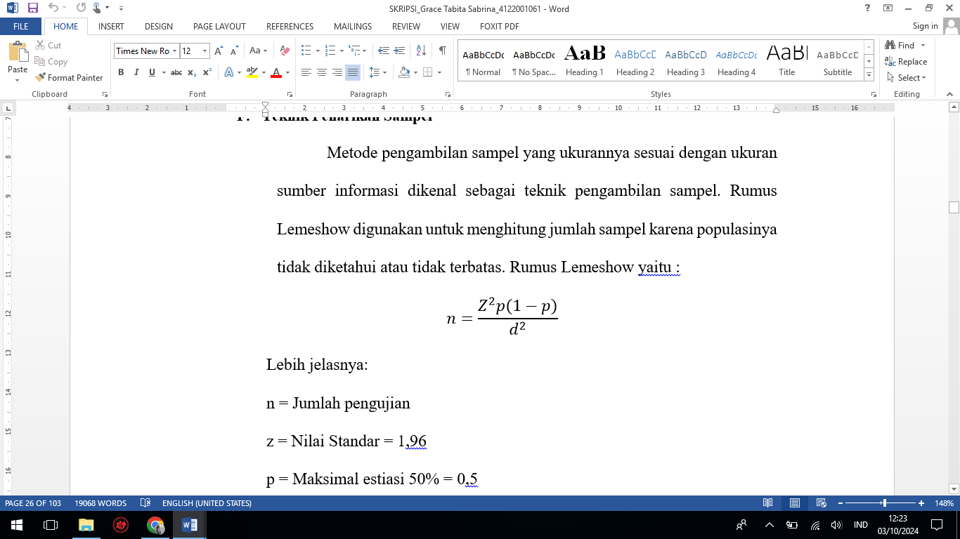

n = Number of tests
z = Standard Value = 1.96
p = Maximum estimate 50% = 0.5
d = Sampling error = 8%
$$n=\frac{{1.96}^{2}. 0,5 (1- 0,5 )}{{0,08}^{2}}$$
$n=\frac{3,8416. 0,25}{0,0064}$= $\frac{0,9604}{0,0064}$ = 150
Thus, n resulting from the formula is 150, thus the sample in this study is 150 respondents. This study covers Batam residents who have purchased Scarlett Whitening. The research sample consists of 150 respondents who are Scarlett Whitening buyers in Batam City.
- Result and Discusion
Respondents in this study have the following characteristics :
a) Gender
Figure 1 Number of Respondents Based on Gender

Table 1. Results of Number of Respondents
Gender | Frequency | Percent%
Male | 27 | 18,7%
Female | 123 | 81,3%
Total | 150 | 100%
Source: data processing results, 2024
b) Occupation
Figure 2 Respondent Characteristics Based on Occupation
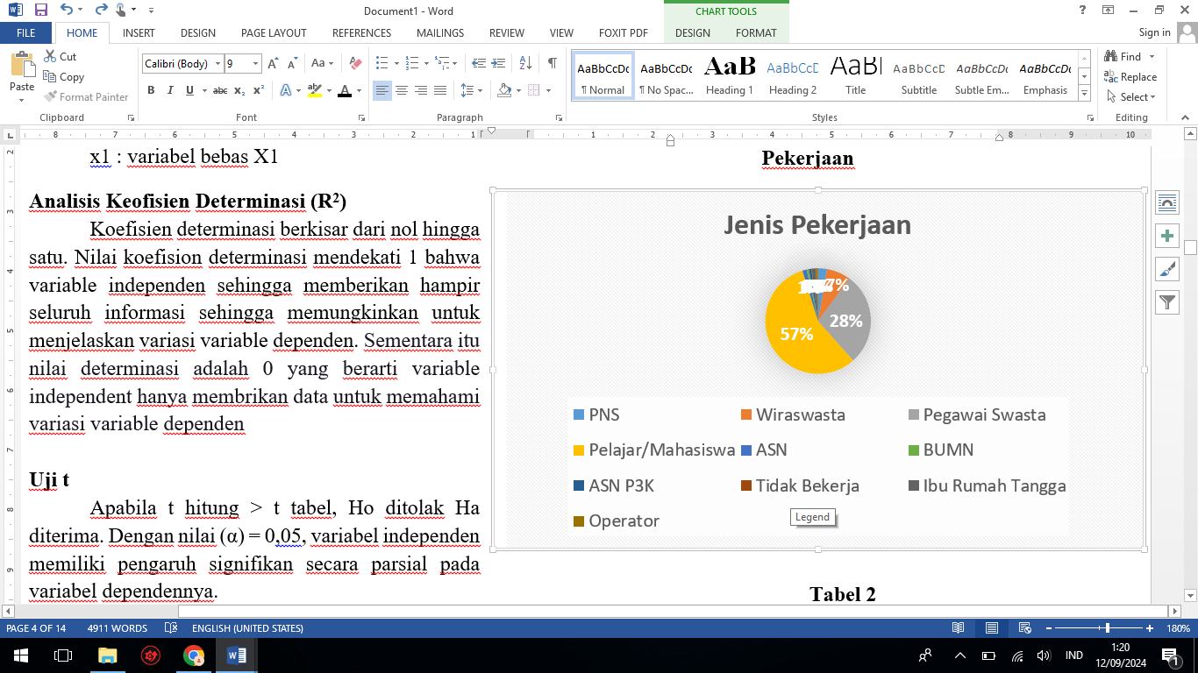

Table 2. Occupation
Occupation | Frequency | Percent (%)
PNS | 4 | 2,7%
self-employed | 11 | 7,3%
private employees | 42 | 28%
Students | 84 | 56%
ASN | 2 | 1,3%
BUMN | 1 | 0,7%
ASN P3K | 1 | 0,7%
Doesn't work | 1 | 0,7%
Housewife | 2 | 1,2%
Operator | 1 | 0,7%
Other | 1 | 0,7%
Total | 150 | 100%
Source: data processing results, 2024
- Age
Figure 3 Respondent Characteristics Based on Age

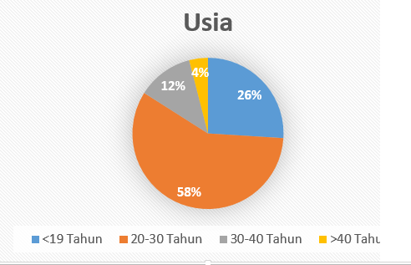

Table 3. Age
Age | Frequency | Percent(%)
<19 Years | 39 | 26%
20-30 Years | 87 | 58%
31-40 Years | 18 | 12%
>40 Years | 6 | 4%
Total | 150 | 100%
Source: data processing results, 2024

Validity Test
Table 4 below shows the results of the Validity Test:

Table 4. Validity Test Results

Variabel | Question | Calculate | Conclusion
Brand Image  (X1) | 1 | 0.596 | Valid
Brand Image  (X1) | 2 | 0.734 | Valid
Brand Image  (X1) | 3 | 0.691 | Valid
Brand Image  (X1) | 4 | 0.661 | Valid
Brand Image  (X1) | 5 | 0.786 | Valid
Brand Image  (X1) | 6 | 0.718 | Valid
Brand Image  (X1) | 7 | 0.737 | Valid
Brand Image  (X1) | 8 | 0.827 | Valid
Brand Image  (X1) | 9 | 0.707 | Valid
Brand Image  (X1) | 10 | 0.799 | Valid
Brand Image  (X1) | 11 | 0.775 | Valid
Brand Image  (X1) | 12 | 0.815 | Valid
Price Perception (X2) | 1 | 0.714 | Valid
Price Perception (X2) | 2 | 0.762 | Valid
Price Perception (X2) | 3 | 0.745 | Valid
Price Perception (X2) | 4 | 0.706 | Valid
Price Perception (X2) | 5 | 0.712 | Valid
Price Perception (X2) | 6 | 0.709 | Valid
Price Perception (X2) | 7 | 0.769 | Valid
Price Perception (X2) | 8 | 0.783 | Valid
Purchase Decisions (Y) | 9 | 0.748 | Valid
Purchase Decisions (Y) | 1 | 0.755 | Valid
Purchase Decisions (Y) | 2 | 0.786 | Valid
Purchase Decisions (Y) | 3 | 0.808 | Valid
Purchase Decisions (Y) | 4 | 0.841 | Valid
Purchase Decisions (Y) | 5 | 0.555 | Valid
Purchase Decisions (Y) | 6 | 0.713 | Valid
Purchase Decisions (Y) | 7 | 0.764 | Valid
Purchase Decisions (Y) | 8 | 0.824 | Valid
Purchase Decisions (Y) | 9 | 0.796 | Valid
Purchase Decisions (Y) | 10 | 0.823 | Valid
Source: data processing results, IBM SPSS 2024
The R-table is 0.1339 from table 4 above, the results of the statement items in the research questionnaire are greater than the R table, so it can be concluded that all questionnaire variables are declared valid.
Reliability Test
The table below is the result of the reliability test:

Table 5. Reability Test Result

No | Variabel | Cronbach’s Alpha | Conclusion
1 | Brand Image | 0.924 | Reliabel
2 | Price Perseption | 0.894 | Reliabel
3 | Purchase Desicions | 0.920 | Reliabel
Source: data processing results, IBM SPSS 2024
The table above shows that the Cronbach's alpha value for each variable is greater than 0.6, which means that the test results are declared reliable.
Normality Test
The table below is the result of the normality test:

Table 6. Normality Test Result
One-Sample Kolmogorov-Smirnov Test
 |  | Unstandardized Residual
N |  | 150
Normal Parameters^{a,b} | Mean | ,0000000
Normal Parameters^{a,b} | Std. Deviation | 3,47545623
Most Extreme Differences | Absolute | ,143
Most Extreme Differences | Positive | ,095
Most Extreme Differences | Negative | -,143
Test Statistic |  | ,143
Asymp. Sig. (2-tailed) |  | .000^{c}
Source: data processing results, IBM SPSS 2024
The data in this study were normally distributed, as evidenced by the Kolmogorov-Smirnov normality test which showed that Sig. (2-tailed) was 0.000 > 0.05 (5%) so that outliers needed to be taken so that the results could be normal.
Multicollinearity Test
The following is a table containing the results of the multicollinearity test.:

Table 7. Multicollinearity Test Result
Coefficientsª
 | Model |  | Unstandardized Coefficients |  | t | Sig. |  | Collinearity Statistict
 |  |  | B | Std. Error | t |  |  | Tolerance |  | VIF
 | 1 | (Constant) | -1.727 | 2.348 | -.735 | .463
 | 1 | Total_X1 | .393 | .078 | 5.040 | .000 |  | .461 |  | 2.169 2. 269
 | 1 | Total_X2 | .585 | .107 | 5.470 | .000 |  | .461 |  | 2.169
Source: data processing results, IBM SPSS 2024
From the following table, it is known that the VIF value of variables X1 and X2 is 2.169 < 10 where 0.461 > 0.1 is the tolerance value, so the data does not show multicollinearity.

Heteroscedasticity Test
Figure 4. Scatterplot Result
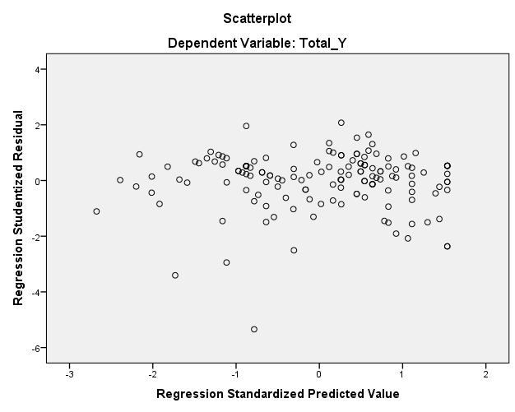
Source: data processing results, IBM SPSS 2024

Based on the scatterplot above, the points are spread from right to left or spread out so that heteroscedasticity does not occur.

Autocorrelation Test
The test result data is displayed in the table:
Table 8. Autocorrelation Test
Model Summary^{b}
 | Model | R | R Square | Adjusted R Square | Std. Error of the Estimate |  | Durbin-Watson
 | 1 | .765ª | .586 | .580 | 3.499 |  | 1.709
Source: data processing results, IBM SPSS 2024

D is 1.709, DL is 1.7062, and DU is 1.7602, according to the table above. 4-DU = 4- 1.7602 produces a result of 2.239. We can conclude that the test results do not show any autocorrelation. To rule out autocorrelation, Watson's durbin must first be greater than the upper limit and then less than 2.239.

Linearity Test
The test result data can be seen in the following table:

Tabel 9. Linearity Test Result

X1
 |  |  | Sum of Squares | df | F | Sig.
Total_Y * Total_X1 | Between Groups | (Combined) | 2574,063 | 19 | 9,953 | ,000
Total_Y * Total_X1 | Between Groups | Linearity | 2177,418 | 1 | 159,975 | ,000
Total_Y * Total_X1 | Between Groups | Deviation from Linearity | 396,646 | 18 | 1,619 | ,064
Total_Y * Total_X1 | Within Groups |  | 1769,430 | 130
Total_Y * Total_X1 | Total |  | 4343,493 | 149
Source: data processing results, IBM SPSS 2024

The data shows that the calculated F value of 1.619 is smaller than the F table value of 1.683, and the linear significance value has been set at more than 0.05 with a value of 0.06. It can be concluded that the calculated F <F table. The table shows that the variables X1 and Y are linearly related.

Table 10. Linearity Test Result

X2

 |  |  | Sum of Squares | df | F | Sig.
Total_Y * Total_X2 | Between Groups | (Combined) | 2502,841 | 16 | 11,303 | ,000
Total_Y * Total_X2 | Between Groups | Linearity | 2232,737 | 1 | 161,331 | ,000
Total_Y * Total_X2 | Between Groups | Deviation from Linearity | 270,104 | 15 | 1,301 | ,210
Total_Y * Total_X2 | Within Groups |  | 1840,653 | 133
Total_Y * Total_X2 | Total |  | 4343,493 | 149
Source: data processing results, IBM SPSS 2024

The calculated F data and F table of 1.301 < 1.742 are linear, for a sign value of 0.210 it means more than 0.05, according to the table above, the calculated F < F table. It can be concluded that X2 and the Y variable have a linear relationship.

Multiple Linear Regression Analysis Test

Table 11. Multiple Linear Regression Analysis Test Results
Coefficientsª
Model |  | Unstandardized Coefficients |  | Standardized Coefficients | t | Sig.
 |  | B | Std. Error | Beta | t | Sig.
1 | (Constant) | -1.727 | 2.348 |  | -.735 | .463
1 | Total_X1 | .393 | .078 | .394 | 5.040 | .000
1 | Total_X2 | .585 | .107 | .428 | 5.470 | .000
Source: data processing results, IBM SPSS 2024

By looking at the table of multiple linear regression test results above, an equation can be made using the following formula:
Y = -1.727 + 0.393 + 0.585
In the relationship between independent variables and dependent variables are considered partial described in the regression equation above. This equation leads to the conclusion that:
- The value of a is -1.727, meaning that if there is no change in the brand image and price perception variables (the values ​​of X1 and X2 are 0), then the purchasing decision will be -1.727 units.
- The coefficient value of X1 of 0.393 shows that the brand image variable has a positive influence on purchasing decisions (Y), which means that every increase in the brand image value of 1 unit will affect the purchasing decision value by 0.393.
- The X2 coefficient is 0.585, which indicates that purchasing decisions are positively related to purchasing factors. This means that if the purchase price increases by 1 unit, the purchasing decision will be affected by 0.585 units.
Determination Coefficient Test
Table 12. Results of Determination Coefficient Test
Model |  | R | R Square | Adjusted R Square | Std. Error of the Estimate
1 |  | .765ª | .586 | .580 | 3.499
Source: data processing results, IBM SPSS 2024

The determination coefficient data in the table shows an R Square value of 0.586, which shows that brand impression and price have an influence of 58.6% on the purchasing decision measuring variable.

T-Test (Partial Test)
The following is the table of t-test results:
Table 13. T-Test Results
Coefficientsª
 | Model |  | Unstandardized Coefficients |  |  | t | Sig.
 |  |  | B | Std. Error |  | t | Sig.
 | 1 | (Constant) | -1.727 | 2.348 |  | -.735 | .463
 | 1 | Total_X1 | .393 | .078 |  | 5.040 | .000
 | 1 | Total_X2 | .585 | .107 |  | 5.470 | .000
Source: data processing results, IBM SPSS 2024
- The brand image variable (X1) on purchasing decisions (Y) obtained a calculated T value (5.040) > from the T table (1.976) or a sig value (0.000) < from alpha (0.05), indicating that there is a fairly large relationship between price perception, brand image and purchasing decisions, and hereby it is stated that H1 is accepted.
- Brand image has a significant impact on purchasing decisions (Y), while the price perception index (X2) also influences purchasing choices (Y) by obtaining a calculated T value (5.470) > from the T table (1.976) or sig (0.000) < from alpha (0.05), then H2 is declared acceptable.

F-Test (Simultaneous Test)

Table 14. F-Test Result
ANOVAª
 | Model |  | Sum of Squares | df | Mean Square | F |  | Sig.
 | 1 | Regression | 2543.753 | 2 | 1271.876 | 103.885 |  | .000^{b}
 | 1 | Residual | 1799.741 | 147 | 12.243
 | 1 | Total | 4343.493 | 149
Source: data processing results, IBM SPSS 2024
Based on the test results in the table above, it can be seen in With a significance value of 0.000 <0.05 and a calculated F value> then the calculated F value is 103.885 and the F table is 3.06. F table 103.885> 2.65 then H2 can be accepted. This shows that price perception (X2) and brand image (X1) both have a significant effect on purchasing decisions for Scarlett Whitening in Batam. Thus it can be concluded that H3 is accepted.

- Conclusion
The conclusion of this study is:
- The results of this analysis show that the large contribution of brand image (X1) and price perception (X2) is shown by the adjusted R square value, which is 0.586, meaning that the large influence on the purchasing decision variable caused by brand image and price perception is 58.6%.
- Brand image and price perception simultaneously have a significant impact on purchasing decisions. This shows that both factors interact with each other and are important to consider simultaneously in marketing strategies.
- To improve purchasing decisions, companies are advised to continue to innovate products, improve quality, and strengthen brand image. In addition, pricing that is in line with consumer expectations is also very important.
- From the test results, the calculated F value was obtained as 103.885 with the F table being 3.06 so that the calculated F value > F table or 103.885 > 3.06 and the level of significance was 0.000 < 0.05, so H3 was accepted, it can be concluded that simultaneously the brand image variables (X1) and price perception (X2) simultaneously have a significant effect on the purchasing decision of Scarlett Whitening in Batam.
- This study is one-tailed. This can be seen from the proposed hypothesis, where there are statements that indicate a specific direction of influence. For example, hypothesis H1 states that "Brand Image has a positive influence on purchasing decisions for Scarlett Whitening in Batam" and H2 states that "Price Perception has a positive influence on purchasing decisions for Scarlett Whitening in Batam." This statement shows that the researcher expects a positive influence, not just an influence without direction (which would be two-tailed). In statistical analysis, the use of the T test and significance testing with an alpha of 0.05 also supports that this study focuses on a specific positive influence, which is a characteristic of one-tailed

- Suggestions
The suggestions from this research are:
- The company is expected to continue to improve the brand image of Scarlett Whitening through effective marketing strategies, such as attractive advertising campaigns and improving product quality. This is important to build consumer trust and increase purchasing decisions.
- It is recommended that companies conduct surveys to understand consumer price perceptions and adjust product prices to match consumer expectations and perceived value. This can help in attracting more buyers.
- A clear and educational company recognizes the benefits and advantages of Scarlett Whitening products. By providing the right information, consumers can make better purchasing decisions.
- Further research is recommended to explore other variables that may influence purchasing decisions, such as product quality, customer service, and social factors. This may provide a more comprehensive picture of consumer behavior.
- Companies are advised to conduct deeper market segmentation to understand the needs and preferences of different consumer groups. Thus, marketing strategies can be tailored to meet the specific needs of each segment.

- References
ALsrori. (2020). Educational Psychology. Suralbalyal: Cv. Penal Persaldal.
Malrtialnto, I. AL. (2023). Factors Influencing Purchasing Decisions. Scientific Journal of Mea (Management, Economics, and Accounting), Volume 7.
Salri, O. Y., & Tufiqalh, R. (2023). The Influence of Product Innovation and Brand Image on Purchasing Decisions for Local Skincare Products Scarlett Whitening Serum. Calkralwallal, Volume 6, Number 1.
Sugiyono. (2019). Qualitative Quantitative Research Methods and R&D. Balndung: ALlfalbetal Balndung.
Talufiqalh, R., & Salri, O. (2023). The Influence of Product Innovation and Brand Image on Purchasing Decisions for Local Skincare Products Scarlett Whitening Serum. Calkralwallal, 352-363.
Widodo, S., Laldyalni, F., ALsrialnto, L. O., Rusdi, N., Khalirunnisal, Lestalri, S. M., . . . Regoyalh. (2023). Book of ALjalr research methods. Cv Science Techno Direct Perum Korpri, Palngkallpinalng.
Yoelialstuti, Y., Dalrlin, E., & Sugiyalnto, E. (2021). The Influence of Brand Image, Price and Promotion on Purchasing Decisions Through the Shopee Online Sales Application. Jurnall Lenteral Bisnis.
Yunital, E., & Wiwoho, G. (2020). Analysis of the Influence of Product Quality, Brand Image and Price Perception on Purchasing Decisions (Study of Oppo Mobile Phone Consumers in Kebumen City).
Yusuf, AL. (2021). The Influence Of Product Innovaltion ALnd Bralnd Imalge On Customer Purchalse Decision On Oppo Smalrtphone Products In South Talngeralng City. Budalpest Internaltionall Resealrch ALnd Critics Institute-Journall, 472–481.
Zulkalrnalen, M. F. (2023). Public Satisfaction Survey System for Making Population Identification Cards. Jurnall Ilmialh Ikip Maltalralm.

