APPROVAL
The Final Project was prepared to fulfill one of the requirements to obtain the degree of Bachelor of Applied Engineering (S.Tr.T)/Associate Degree in Engineering (AMd.T.)
In

Politeknik Negeri Batam
By:

Bintang Naldika Al-Farras (3222101047)

Seminar date: 24 July 2024

Approval by :




1. Hana Mutialif MaulidIah, S.T.,  M.Sc. NIK:120241 | 1. Nadhrah Wivanius, S.Si.,  M.Si. NIK:115141
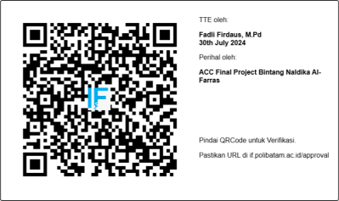  2. Fadli Firdaus, S.Pd., M.Pd. NIK:122271 | 3

