The Implementation of Digital Payment and Its Impact on User Decision in Batam City
Abdun Naim¹ and Ayu Puspitasari²

{abdunnaim119@gmail.com¹ ayupuspitasari@polibatam.ac.id²}

Politeknik Negeri Batam, Business and Management Department, Batam City, Indonesia
Abstract. The digital transformation within the financial system has facilitated the widespread adoption of digital payments across society. This study aims to examine the influence of motivation, perception, and consumer behavior on user decision-making in the context of digital payment usage in Batam City. This study applied a quantitative research design through a survey approach, involving 101 participants chosen via purposive sampling technique. The data were analyzed using Structural Equation Modeling with the Partial Least Squares (SEM-PLS) technique. The findings reveal that consumer motivation and behavior have a statistically significant effect on user decisions, whereas perception does not exhibit a significant impact. This study contributes empirical evidence that may enrich theoretical perspectives in the field of digital payment and offers practical implications for digital financial service providers in developing strategies that enhance user motivation, perception, and behavior in relation to decision-making.
Keywords: Digital Payment, Consumer Motivation, Consumer Perception, Consumer Behavior, User Decision.
- Introduction
The Fourth Industrial Revolution (4.0 Industry) has driven substantial changes across various sectors, particularly through the increasing integration of digital technologies. In this era, information and communication technologies have advanced rapidly and become embedded in daily activities, including those in the financial and business sectors. Financial technology (fintech) represents the application of technological advancements within financial systems, resulting in new forms of services, products, and business models. These innovations have contributed not only to the stability of the financial system but also to improved efficiency and security in payment systems [1]. Currently, there are five types of fintech that are rapidly developing in Indonesia, namely: (1) crowdfunding, (2) microfinancing, (3) peer-to-peer (P2P) lending services, (4) market comparison platforms, and (5) digital payment systems. The digital payment category includes services that facilitate the payment of various bills—such as mobile credit, credit cards, electricity tokens, and others—without requiring the user to carry or store physical cash [2]. The operational mechanism of digital payment methods relies heavily on technology, particularly internet connectivity [3]. The use of digital payment not only offers convenience to users but also facilitates transaction recording and tracking [4].
Katadata.co.id it is reported that in 2024, the digital payment sector in Indonesia experienced significant growth. The transaction value for top-up services reached IDR 875.05 trillion, while digital spending transactions amounted to IDR 372.91 trillion. Additionally, electronic money transfers accounted for IDR 350.44 trillion. The QRIS (Quick Response Code Indonesian Standard) segment also saw a remarkable annual growth of 226.54%, A total of 50.50 million users and 32.71 million merchants were recorded [5]. On the other hand, digital banking transactions increased by 54.89% as of September 2024. The advancement of digital technology has driven a significant transformation in financial transaction systems, particularly through the adoption of digital payment methods. Digital payment systems such as QRIS, e-wallets, and mobile banking have provided faster, safer, and more efficient alternatives compared to conventional payment methods [6]. One clear example of this transformation is the shift in consumer behavior from offline to online shopping. A review of several studies reveals differing perspectives on the concept of the digital economy. From an economic standpoint, digitalization can contribute to reducing national inflation, while the rise of online shopping behavior represents a broader societal shift—indicating that communities are increasingly reliant on digital payment systems to support their business activities [7].
As an industrial and commercial hub, Batam City has demonstrated rapid growth in the use of digital payments, in line with the increasing accessibility of financial technology infrastructure. Batam City has experienced rapid development in the adoption of digital payment systems. The use of QRIS has emerged as the dominant payment method, followed by the increasing popularity of e-wallets among the public. The ongoing digitalization in Batam and the reasons behind digital payment usage are clearly illustrated below.
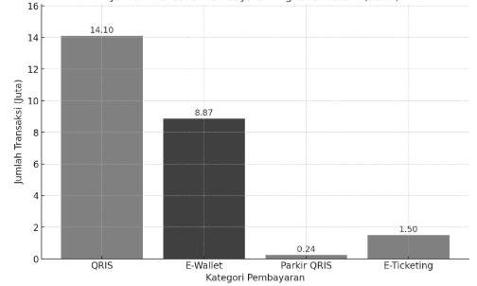
Fig. 1. Digital Payment Transaction Data in Batam City for the Year 2024
Source: Batamnews.co.id (2024)
Based on Figure 1, it can be observed that QRIS transactions dominated digital payments in Batam City in 2024, with the number of transactions exceeding 14 million. The use of e-wallets is also relatively high, although not all users utilize them regularly. The implementation of QRIS payments for parking and port e-ticketing systems remains in its early stages but shows an upward trend, in line with increasing public awareness of the convenience offered by digital payments. With continuous technological advancement and supportive government policies, the adoption of digital payments in Batam City is expected to grow further in the coming years.
Several dimensions of digital payment have been identified, including: (1) perceived benefit, (2) perceived enjoyment, (3) perceived ease of payment, (4) perceived speed, (5) security (6) efficiency [8]. Negative phenomena associated with digital payments have been reported in several studies for instance, found that security concerns are a major factor influencing individuals' decisions not to use digital payment systems [9]. trust plays a significant role in influencing users' consumptive behavior [10]. Based on the phenomena described, this study focuses on examining the impact of digital payment implementation on user decision-making. The implementation of digital payment is assessed through indicators such as consumer motivation, perception, and behavior in influencing digital payment usage decisions. Batam City was selected as the research site due to its status as an industrial and commercial center with notable digital technology growth. The primary objective of this study is to analyze the effects of motivation, perception, and consumer behavior on digital payment decision-making in Batam City.
- Literature Studies
  - Digital Payment
Digital payment is an innovation within the modern payment system that has become increasingly popular across various segments of society. This method offers several advantages, including time efficiency, ease of access, enhanced customer loyalty, and relatively low administrative costs. However, the use of digital payment systems also presents certain drawbacks, such as potential misuse, the risk of personal data breaches, reliance on internet connectivity, and limitations associated with specific application platforms. Digital payment involves the use of electronic devices equipped with specific code-scanning technology, thereby requiring specialized tools to process transactions [11]. Its emergence represents a form of technological advancement powered by artificial intelligence, which adaptively supports financial transaction activities in various aspects of digital life.
  - Consumer Motivation
Consumer motivation refers to an internal condition within an individual that drives the desire to engage in activities aimed at achieving specific goals [12]. Motivation can be interpreted as a state of arousal influenced by external stimuli, prompting individuals to cooperate and perform tasks with maximum effort in order to attain satisfaction. There are two main types of motivation: positive motivation, which includes needs, desires, or incentives such as discounts, rewards, and other benefits; and negative motivation, which involves fear or reluctance, such as limited-time offers that pressure consumers to make a purchase. Despite their differences, both types of motivation serve the same function—stimulating and sustaining human behavior [13].
  - Consumer Perception
In addition to motivation, consumer perception also plays a crucial role in influencing user decisions. Perception refers to the process through which individuals select, organize, and interpret information to construct a meaningful understanding of their surroundings [14]. Understanding the social background and population characteristics is a critical aspect in designing appropriate measurement instruments and sampling techniques, ensuring that the data collected are more accurate and relevant to the research context [15]. The scope of consumer perception encompasses various aspects, as it involves the study of evolving processes through which individuals or groups select, use, or make choices regarding products, services, ideas, or experiences that satisfy their needs and desires [16].
  - Consumer Behavior
Consumer behavior is the study of the evolving processes by which individuals or groups select or make choices that satisfy their needs and desires [17]. Consumer behavior It encompasses the activities directly related to acquiring, using, and disposing of goods and services, along with the decision-making processes that precede and influence these activities. Indicators of consumer behavior consist of cultural, social, personal, psychological, and technological factors [18].
  - User Decision
As the dependent variable in this study, user decision-making reflects the final outcome of the interaction between motivation, perception, and consumer behavior. Purchase decision-making is one of the stages in a series of processes that occur during buying and selling transactions at a specific time and period conducted by consumers. This process involves three main activities: routine purchasing behavior, the perception of quality derived from the decision, and habitual purchasing by consumers who are committed to competing products [19]. Purchase decisions involve a sequence of choices made by consumers prior to making a purchase, beginning with the intention to fulfill a need. In reaching a purchase decision, consumers must consider several factors, including the place of purchase, preferred brand, product model, quality, timing, amount of money to be spent, and the method of payment [20]. Every decision made has a structure that constitutes a crucial and determining component, including the method of payment for the product to be purchased [21].
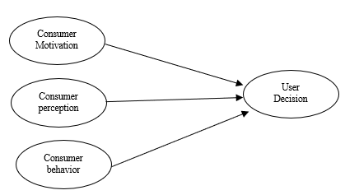
Fig. 2. Conceptual Framework

Hypotheses:
H1: Consumer motivation has a significant influence on user decision-making in digital payment.
H2: Consumer perception has a significant influence on user decision-making in digital payment.
H3: Consumer behavior has a significant influence on user decision-making in digital payment.
- Methodology
  - Research Method
This research utilized a quantitative design through the application of a survey method. The sampling technique applied was purposive sampling, involving 101 respondents from the community in Batam City. The study drew upon both primary and secondary data sources. Primary data were collected through questionnaires distributed via Google Forms, while secondary data were obtained from previous journal articles. The questionnaire items were measured using a Likert scale with four response options: strongly disagree, disagree, agree, and strongly agree.
Data processing involved descriptive and statistical analysis using Structural Equation Modeling with the Partial Least Squares (SEM-PLS) approach. Measurement model evaluation (outer model) was conducted through convergent validity and discriminant validity tests, while the structural model (inner model) was assessed by examining the R-square values. Classical assumption tests included normality, heteroscedasticity, and multicollinearity tests. Reliability was assessed using Cronbach’s Alpha, and hypothesis testing was performed to determine the significance of relationships between variables based on empirical data.
- Result and Discussion
  - Respondent Profile
A total of 101 respondents were obtained through the online distribution of questionnaires, serving as the research sample. The respondent profile includes gender, age, occupation, and frequency of digital payment usage. The detailed characteristics of the respondents are presented as follows:
Table 1. Respondent Profile
Category | Subcategory | Frequency (n) | Percentage (%)
Gender | Male | 45 | 44,55%
 | Female | 56 | 55,45%
Age | 20-25 | 52 | 51,49%
 | 26-30 | 29 | 27,71%
 | 31-35 | 15 | 14,85%
 | 36-40 | 5 | 4,95%
Occupation | Private Employees | 58 | 57,43%
 | Students | 26 | 25,74%
 | Entrepreneurs | 4 | 3,96%
 | Other | 13 | 12,87%
Usage Frequency | Repeated usage | 96 | 95,05%
 | Single-time use | 5 | 4,95%
  - Outer Model Evaluation
This section presents the results of the outer model testing, which are assessed through convergent validity and Average Variance Extracted (AVE), as shown below.
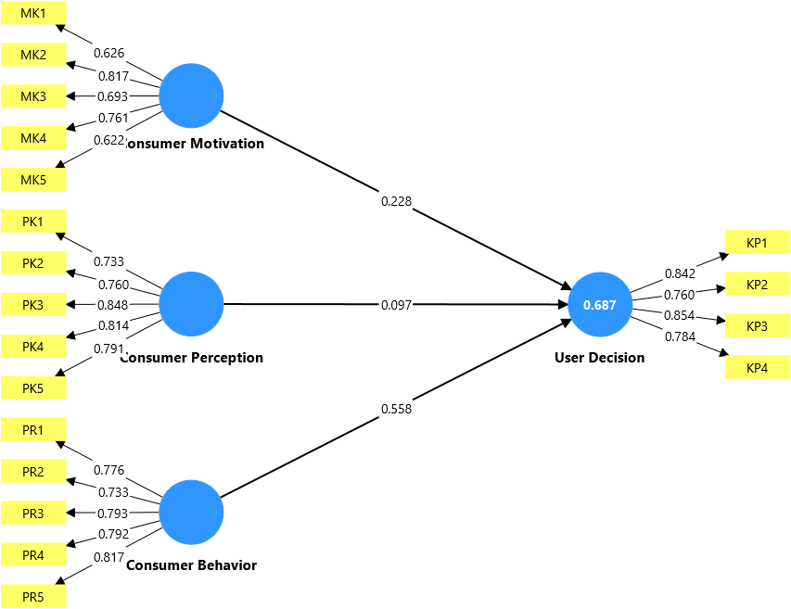
Fig. 3. Outer Model
Table 2. Output Outer Model
 | Consumer Motivation | Consumer Perception | Consumer behavior | User Decision
Problem Recognition |  |  |  | 0.842
Information Search |  |  |  | 0.760
Alternative Evaluation |  |  |  | 0.854
Post-purchase Behavior |  |  |  | 0.784
Basic Needs | 0.626
Safety Needs | 0.817
Social Needs | 0.693
Ego Needs | 0.761
Self-actualization Needs | 0.622
Speeds Up Work |  | 0.733
Increases Productivity |  | 0.760
Effectiveness |  | 0.848
Makes Work Easier |  | 0.814
Useful |  | 0.791
Cultural Factors |  |  | 0.776
Social Factors |  |  | 0.733
Personal Factors |  |  | 0.793
Psychological Factors |  |  | 0.792
Technological Factors |  |  | 0.817
Average Variance Extracted (AVE) | 0.501 | 0.624 | 0.613 | 0.658
Based on Table 2, all indicators within each construct satisfied the established criteria for convergent validity. Although one indicator under the consumer motivation variable has a loading value of 0.501, it is still considered acceptable because the Average Variance Extracted (AVE) for that construct remains above the threshold of 0.50. Therefore, the measurement model (outer model) in this study is considered valid and acceptable.
The reliability of the outer model is supported by Cronbach’s Alpha and Composite Reliability, as shown in the following results:
Table 3. Output Cronbach's Alpha dan Composite Reliability
 | Cronbach’s Alpha | Composite Reliability
User Decision | 0.827 | 0.895
Consumer Motivation | 0.749 | 0.832
Consumer Behavior | 0.841 | 0.888
Consumer Perception | 0.849 | 0.892

Subsequently, Table 3 shows that the Cronbach’s Alpha and Composite Reliability values for all observed constructs fall within the acceptable threshold of 0.70 or higher. These results indicate that the reliability requirements of the outer model have been satisfactorily fulfilled.
  - Structural Model Evaluation
Upon meeting the requirements of the outer model, the next step is to evaluate the inner (structural) model by examining the R-Square (R²) values obtained from the output:
Table 4. Output inner model R-Square
 | R-Square
User Decision | 0.687

Based on the data in Table 4, the inner model output shows that the R-Square (R²) value for the dependent variable User Decision is 0.687. This indicates that the independent variables explain 0.687of the variance in the user decision construct, which falls into the moderate category.
  - Hypothesis Testing Results
Hypothesis testing in this study was conducted using the bootstrapping technique in SmartPLS. A hypothesis is considered supported if the T-statistic > 1.96 and the significance value (p-value) < 0.05. Conversely, the hypothesis is rejected if the T-statistic < 1.96 and the p-value > 0.05. The results of the bootstrapping analysis are presented in the following table.
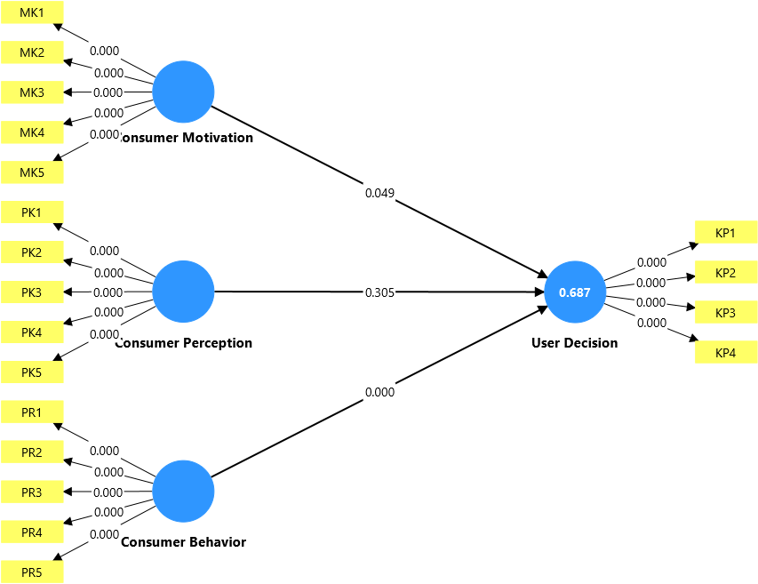
Fig. 4. Bootstrapping Output Model
After performing the bootstrapping procedure in SmartPLS, hypothesis testing is conducted by examining the path coefficients, as presented in the analysis below:
Table 5. Bootstrapping Output Model
 | T-Statistic | P-Values | Result
Consumer Motivation -> User Decision | 1.969 | 0.049 | Accepted
Consumer Perception -> User Decision | 1.027 | 0.305 | Rejected
Consumer Behavior -> User Decision | 5.118 | 0.000 | Accepted

Based on Table 5, which presents the bootstrapping output of the structural model, the results will be elaborated in detail through the following explanations.

The bootstrapping output above shows that the variable of consumer motivation (H1) obtained a T-statistic value of 1.969 and a P-value of 0.049, indicating that T > 1.96 and P < 0.05. These results suggest that the implementation of digital payment, in terms of consumer motivation, significantly influences user decision-making. This finding is consistent with the study conducted by Handayani and Rahmantari (2024) which found that external motivation in the adoption of digital payment is strongly influenced by social factors, including the surrounding environment, family, and the broader community [22]. One of the main factors shaping a positive attitude toward digital payment is the individual's perception of the convenience and practicality it offers. The ease of use provided by digital payment systems is also a key reason why many people choose this technology. This perception reinforces the belief that the implementation of digital payment simplifies transaction processes by eliminating the need for cash, ultimately enhancing user convenience.
The bootstrapping output above shows that the consumer perception variable (H2) obtained a T-statistic value of 1.027 and a P-value of 0.305, indicating that T < 1.96 and P > 0.05; therefore, the hypothesis is rejected. These results suggest that the implementation of digital payment, in terms of consumer perception, does not significantly influence user decision-making. This finding is consistent with the study conducted by Maysari et al., (2024) hich found that the use of digital payment may depend on the specific platform utilized. If users engage with a particular digital payment platform that does not align with their expectations, it may negatively affect their perception of the platform [23]. This result also reinforces the theory of consumer perception, which posits that perception is an initial interpretation of a stimulus; however, the final decision is often influenced by other factors such as habits, social influence, and actual experience [24]. This implies that consumer perception in this study can be considered relatively neutral, as most respondent transactions were primarily limited to daily necessities, making the implementation of digital payment less frequent.
he bootstrapping output above shows that the consumer behavior variable (H3) obtained a T-statistic value of 5.118 and a P-value of 0.000, indicating that T > 1.96 and P < 0.05. These results suggest that the implementation of digital payment, in terms of consumer behavior, is the second variable found to significantly influence user decision-making. This finding is also consistent with the study conducted by (karmaker, et al., 2025) Users who perceive the application as easy to use and trustworthy tend to use it more frequently and recommend it to others [25]. This finding is also in line with the study conducted by Maysari et al (2023) which found that user behavior emerges from cultural, social, psychological, and technological factors, all of which contribute to the formation of a new culture surrounding the use of digital payments [26]. The findings on consumer behavior in this study suggest that the people of Batam City possess a distinct concept shaped by attitudes, responses, and thought processes, as well as individual and group decision-making patterns in adopting digital payment systems.
- Conclusion
Based on the hypothesis testing results, consumer motivation was identified as the first variable that significantly influenced the decision to use digital payments in Batam City. Consumer perception, on the other hand, did not have a significant effect. Consumer behavior, meanwhile, was identified as the second variable exerting a strong and significant impact on decisions regarding digital payment usage.
- Research Limitations
This research presents several limitations that need to be taken into account when interpreting its findings. First, the cross-sectional approach only captures conditions at a single point in time and does not reflect the dynamic changes in consumer behavior over the long term. Second, the use of purposive sampling with a limited number of respondents from Batam City restricts the extent to which the findings can be generalized to other regions or populations. Third, the use of self-report questionnaires introduces the possibility of subjective bias, such as social desirability bias. Fourth, the variables analyzed in this study were limited to motivation, perception, and consumer behavior, and did not include external indicators such as system security, regulatory support, or technological maturity, which may also influence digital payment user decisions.
- Suggestion
- his study highlights the importance of focusing digital payment adoption strategies on shaping consumer behavior, particularly in terms of convenience, social influence, and technological ease of use.
- Given that this study is limited to the population of Batam City, future research is recommended to be conducted in different regions or by employing a qualitative approach to further explore the implementation of digital payment in relation to user decision-making. Additionally, future studies should consider including other unexplored variables that may potentially influence digital payment adoption.

References
- Indonesia, B. (2020). Teknologi finansial dan stabilitas sistem keuangan. Jakarta: Bank Indonesia Bawono, W., Nugroho, A., & Setiawati, E. (2018). Ruang lingkup perilaku konsumen. Jurnal Manajemen Pemasaran, 55-70.
- Keuangan, Otoritas jasa;. (2018). Fintech dan jenis-jenisnya di Indonesia. Jakarta: OJK Press.
- Tarantang, J. A. (2019). Jurnal Al-Qardh. Perkembangan sistem pembayaran digital pada era revolusi industri 4.0 di Indonesia, 60-75.
- Mubarak, R. S. (2022). Penggunaan digital payment . Journal of Financial Technolog, 23-40.
- https://databoks.katadata.co.id (Data pembayaran digital Indonesia tahun 2024)
- Otoritas , J. K. (2021). Transaksi QRIS dan perkembangan sistem pembayaran digital. web page.
- Abdillah, A. P. (2022). Perubahan perilaku konsumen dalam ekonomi digital. Jurnal Ekonomi Digital, 45-58.
- Rizkiyah, R. P. (2021). Digital payment dan keamanannya dalam transaksi online. Jurnal Teknologi Keuangan, 45-60.
- Maysari, N., Pristiyono, & Nasution, M. F. (2023). Implementasi digital payment dan dampaknya pada keputusan pengguna. Jurnal Ekonomi dan Bisnis, 77–89.
- Safira, R., Sugianto, S., & Harahap, R. D. (2023). Pengaruh kepercayaan, kemudahan, dan manfaat digital payment sebagai alat pembayaran terhadap perilaku konsumtif individu dengan digital savvy sebagai variabel moderating. Keuangan & Bisnis Syariah, 2859–2878.
- Gunawan, A.;. (2019). Digital payment dan perkembangannya di era digitalisasi. Jakarta: Penerbit Digital Nusantara.
- Wardhana, A. (2024). Perilaku Konsumen di Era Digital. Purbalingga: CV. Eureka Media Aksara.
- Rossanty, Y. S. (2018). Motivasi konsumen dan pengaruhnya terhadap keputusan. Journal of Consumer Studies, 20-37.
- Kotler , P., & Amstrong, G. (2008). Principles of marketing. Pearson Education.
- Kumara, R. (2021). Teknik sampling dalam penelitian sosial: Konsep dan aplikasi. Jurnal, 120-135.
- Bawono, W., Nugroho, A., & Setiawati, E. (2018). Ruang lingkup perilaku konsumen. Jurnal Manajemen Pemasaran, 55-70.
- Bawono, W., Nugroho, A., & Setiawati, E. (2018). Ruang lingkup perilaku konsumen. Jurnal Manajemen Pemasaran, 55-70.
- Suprajang, D., & Wijaya, R. (2015). Faktor-faktor yang mempengaruhi perilaku . Jurnal Manajemen Pemasaran, 70-85.
- Hahn, T. (2022). Keputusan pembelian konsumen dalam era digital. Journal of Consumer, 101-115.
- Hanaysha, J. (2018). Pengaruh perilaku konsumen terhadap keputusan pembelian. Journal of Business and Marketing, 85-99.
- Lestari, S., & Yusuf, R. (2021). Analisis keputusan pembelian dan faktor yang . Jurnal Manajemen, 34-50.
- Handayani, M. M., & Rahmantari, N. L. (2024). Motivasi dan tantangan adopsi mobile payment: Perubahan perilaku konsumen dan transformasi industri keuangan. Jurnal Keuangan Digital, 55-72.
- Maysari, N., Pristiyono, & Nasution, M. F. (2023). Implementasi digital payment dan dampaknya pada keputusan pengguna. Jurnal Ekonomi dan Bisnis, 77–89.
- Kotler , P., & Amstrong, G. (2008). Principles of marketing. Pearson Education
- Karmaker, S. C., Rahman, M. M., Islam, M. M., & Sadekin, M. N. (2025). Exploring influential factors of consumer purchase behavior on the adoption of digital payment apps in Bangladesh. nternational Journal of Business and Management Future, 01–10
- Maysari, N., Pristiyono, & Nasution, M. F. (2023). Implementasi digital payment dan dampaknya pada keputusan pengguna. Jurnal Ekonomi dan Bisnis, 77–89

