

Reduce Pick Arm Lead Frame Drop in Dedam Dejunk Machine

Final Project

by:
Bintang Naldika Al-Farras (3222101047)

Program Studi Teknik Elektronika Manufaktur Jurusan Teknik Elektro
Politeknik Negeri Batam 2024
1

STATEMENT OF AUTHENTICITY OF FINAL PROJECT

I the undersigned declare that the contents of part or all of my Final Project entitled: "Reduce Pick Arm Lead Frame Drop in Dedam Dejunk Machine" is the result of my own work, completed without using unauthorized materials, and is not the work of other parties that I recognize as my own work. All references quoted or referred to have been written in full in the bibliography. If it turns out that my statement is not true, I am willing to accept sanctions according to applicable regulations.

Batam, 3 Juli 2024
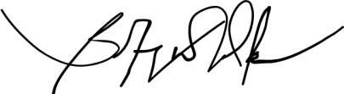

Bintang Naldika Al-Farras NIM: 3222101047

APPROVAL
The Final Project was prepared to fulfill one of the requirements to obtain the degree of Bachelor of Applied Engineering (S.Tr.T)/Associate Degree in Engineering (AMd.T.)
In
Politeknik Negeri Batam By:
Bintang Naldika Al-Farras (3222101047)

Seminar date: 24 July 2024

Approval by :




1. Hana Mutialif MaulidIah, S.T.,  M.Sc. NIK:120241 | 1. Nadhrah Wivanius, S.Si.,  M.Si. NIK:115141
  2. Fadli Firdaus, S.Pd., M.Pd. NIK:122271 | 3

Reduce Pick Arm Lead Frame Drop on Dedam Dejunk Machine
Bintang Naldika Al-Farras ¹, Nadrah Wivanius, S.Si., M.Sc 1
Polytechnic State of Batam, Batam, Indonesia Email: bintangnldk@gmail.com

Abstract— Dedam dejunk is a process to cut the dambar and remove the degate on the lead frame. Dedam dejunk process has a pick arm that functions to move the lead frame. But after being researched this dedam dejunk process has time slowness. The slowness that occurs is caused by the lead frame dropping from the pick arm. So, the machine experiences downtime by occurrence. The purpose of this study is to learn how to reduce lead frame drop in this dedam dejunk process. This study uses the fishbone method, analyzed through a table filled with verification to find the truth. Finding the root cause that has been found from the verification is continued with the 5 why analyze. 5 Why is looking for the verification assumption to find the root cause so that it can be solved. The root cause of the problem is the parameter and the bent plate. The elevator parameter that makes the pick arm not reach to pick up the lead frame. in addition to the elevator, the plate affects the tilt of the lead frame which makes the sensor on the pick arm untouched. that is why a new plate is needed. Reduce from the improvement resulted in 37,85 percent of the data that had been taken.

Keyword: Dedam dejunk process, Fishbone, Lead frame drop, 5 Why analyze

  - INTRODUCTION
Integrated Circuit or shortened with IC is an active electronic component consisting of a combination of hundreds, thousands and even millions of transistors, diodes, resistors and capacitors that are integrated into an electronic circuit in a small package. Silicon is the main material that makes up an Integrated Circuit (IC). [1]
In the manufacturing Industry especially IC manufacturing, there are a number of processes one of them is dedam dejunk. Dedam dejunk is the process of cutting the dambar and degate the lead becomes a unit
The machine has a pick arm to pick up the lead frame from the magazine holder and move it to the lead frame track for the next process. But not all picked lead frames have the same drop point on the lead frame track. There are several factors that can cause a lead frame drop. Every time a lead frame drop occurs,
it will cause the process on the machine to stop because the machine will send a message from the error that occurred to the operator monitor which is currently running the dedam dejunk process.
The pick arm lead frame drop has many error messages that slow down the dedam dejunk process time. As more and more error messages occur, more and more time is wasted just to fix the error.

  - METHOD
QC Seven Tools - QC Seven Tools are 7 (seven) basic tools used to solve problems faced by production, especially on problems related to quality. [2]
Flowchart.
Flowchart is a diagram that displays the steps and decisions to perform a process of a program. Each step is described in the form of a diagram and connected by lines or arrows. Below is a flowchart of how the pick arm lead frame drop error occurs.
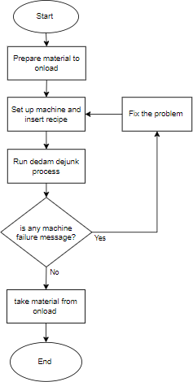
Figure 1. Reasearch flowchart

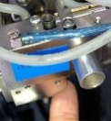
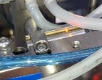
Fishbone diagram
Parameter vacuum
pressure (after)
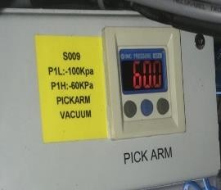
Figure 6. Parameter vacuum pressure after

Conclusion: The pressure should be at -60Kpa to - 100Kpa.
 | Clogged vacuum filter |  | Vacuum filter before cleaning |  |  | No
 | Clogged vacuum filter | 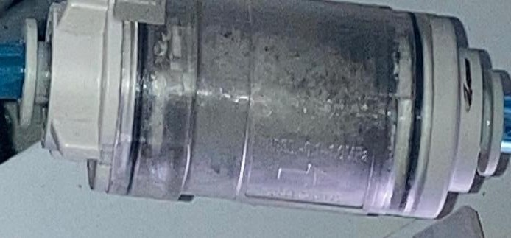  Figure 7. Vacuum filter before cleaning  Vacuum filter after cleaning  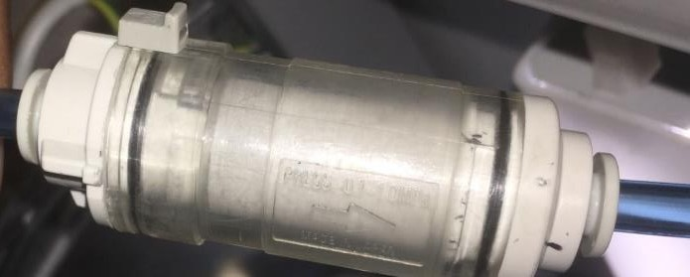  Figure 8. Vacuum filter after cleaning  Conclusion: The vaccum filter must be cleaned so the vaccum pressure does not decrease from the parameter. |  |  |  | No
 | Sensor stuck | How to know sensor stuck or not?  Step 2  Step 1  Figure 9. Sensor  Step:  - Push the pin  - Light will turn on into red    Step 4  Step 3  Figure 10. Sensor  Step: |  |  |  | No

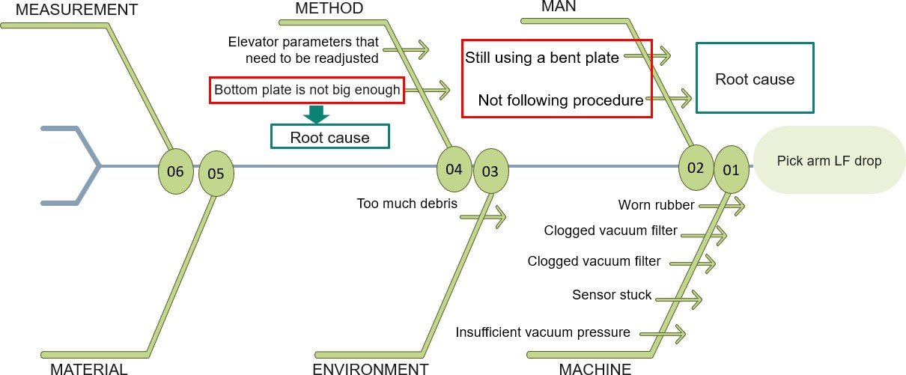
Fishbone diagrams are frameworks used to help identify and solve business problems. It is called so, because this diagram has a shape like a fishbone. This diagram is useful to help identify problems and their solutions, in the business and personal world. [3]
Figure 2. Fishbone diagram

Root cause analyze
Table 1. Root cause analyze

Item | Hypothesis | Verification |  |  | Root  Cause?
Environment | Too much debris | 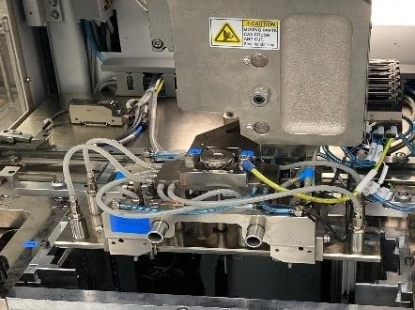  Figure 3. Pick arm area  Debris doesn't disturb pick and place |  |  | No
 | Worn  rubber | 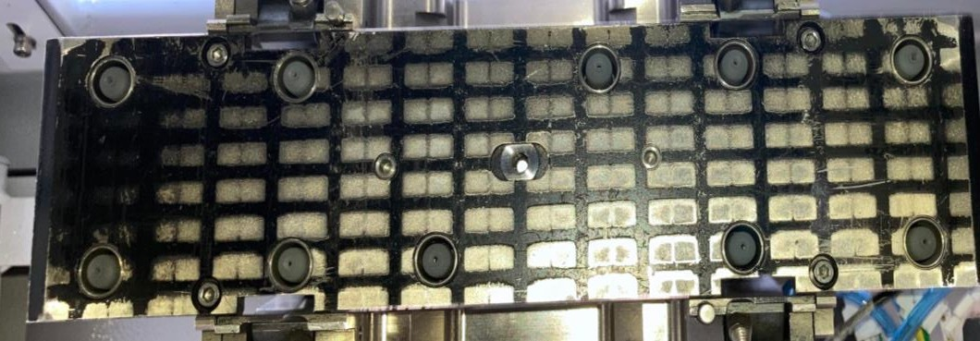 |  |  | No
 |  | Figure 4. Rubber cup
 | Missing vacuum cup | The rubber used is not worn |  |  | No
 |  | out and is not missing.
 |  |  | Parameter vacuum
 |  |  | pressure (before)
Machine |  | 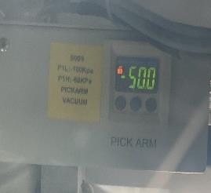
 | Insufficient  vacuum pressure | Figure 5. Parameter vacuum pressure before |  |  | No
 |  | After the procces, we need to clean the vacuum filter to make pressure sufficient during procces

5 Why analyze
- Push the pin from button until pin go at the top
- Light will turn off
Conclusion: The sensor detected the pin with changing light
Method | Elevator parameters that need to be readjusted | 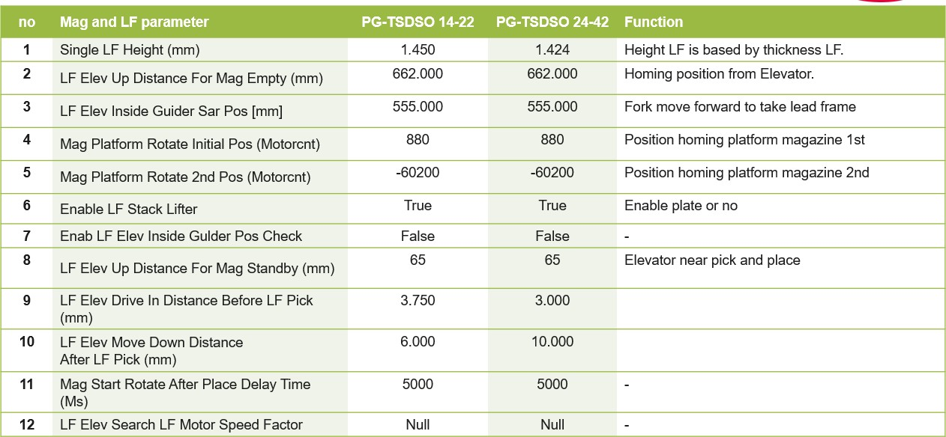  Figure 11. Parameter mag and lf  because there are differences in magazine and leadframe parameters  with the same package |  |  |  |  |  | Yes
Method | Bottom plate is not big enough | 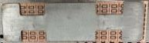  Figure 12. Plate versus LF  The bottom plate does not fully support the LF. |  |  |  |  |  | Yes
Man | Not following procedure | Mold remain |  |  |  |  |  | Yes
Man | Not following procedure | Figure 13. Mold remain  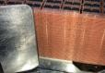  Figure 14. Still used bent plate    The operator use the plate for cleaning remain mold. Its make the plate bent  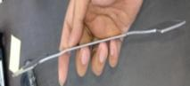  Figure 15. Bent plate    Conculsion: This plate is still using by operator for production |  |  |  |  |  | Yes
Man | Still using a bent plate |  |  |  |  |  |  | Yes

Table 2. Root cause analyze
Problem | Bottom plate is not big enough
Why? | Small design plate
Why? | Plate does not cover all areas of the lead frame
Why? | Make the lead frame bowing
Root cause? | Redesign the plate that covers all areas of the leadframe so that it does not become bowing so that the pick arm can reach all areas of the  leadframe and touch the sensor on the pick arm.
From the 5 why analyzed, the problem is a bent plate so it can be concluded that the damage to the plate is not large enough to increase the error that occurs in the dejunk dedam machine. It is necessary to look again at the previous design so that all lead frames can be supported by the plate, so that there is no bowing that causes the lead frame to drop as it is.

Table 3. Root Cause analyze

Problem | Still using a bent plate and not following  procedure
Why? | The operator use the plate for cleaning remain  mold.
Why? | Insufficient plate availability
Why? | Will interrupt the process that works on the  machine
Root cause? | Create new plates in order to meet the availability requirements


From the 5 why analyzed, the problem is still using bent plates and not following the procedure so it can be concluded that plate damage can reduce the amount of plate stock in the production area. It is necessary to conduct retraining so that man can follow the procedure properly so that the goods used follow the standardization should be.
Tools
The following is the equipment used to conduct this research:
    - Dedam dejunk machine.
This machine uses for cut the dambar and remove dejunk.
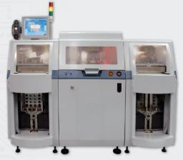
Figure 16. Dedam dejunk machine [4]

    - Application
During this research there is application used to be able to see the downtime machine value on the machine.

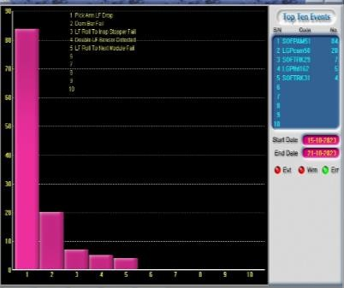
Figure 17. Application for take data

    - Material
There are 3 types of materials that will be used during the research including package TSDSO 14-22, TSDSO 24-42, and TSDSO 24-32.

Package TSDSO 14-22 has a body length of 4.9mm and a body width of 3.9mm. Have 12 terminals and a minimum terminal pitch of 0.65mm. Below is example the package.

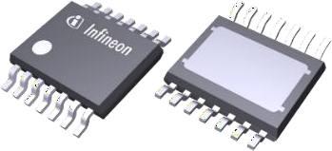
Figure 18. Package TSDSO 14-22 [5]

Package TSDSO 24-42 has a body length of 8.65mm and a body width of 3.9mm. Have 12 terminals and a minimum terminal pitch of 0.65mm. Below is example the package.

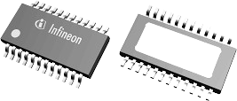
Figure 19. Package TSDSO 24-42 [5]

Package TSDSO 24-32 has a body length of 8.65mm and a body width of 3.9mm. Have 12 terminals and a minimum terminal pitch of 0.65mm. Below is example the package.
After collect the data, we will compare the data before and after. whether it has reduced or not.

Here's how to determine the comparison of two data:
- Determining the Starting Value and Final Value
The first step is to determine the initial and final values to be compared. For example, we want to find the percentage comparison of the number of app users before and after the new development is launched.

- Calculating the Difference Between the Initial Value and the Final Value
The second step is to calculate the difference between the initial value and the final value. For example, if we find that the number of app users before the new development was 1000 and after it became 1500, then the difference is 500.

- Calculating Percentage Comparison using the Formula
After knowing the difference between the initial value and the final value, we can calculate the percentage comparison using the following formula:

Percentage Comparison = (Difference / Initial Value) x 100 [6]

  - RESULT AND DISCUSSION
Monitoring is done every week to see how many errors occur on the dedam dejunk machine. Improvements made after analyzing the root of the problem to reduce errors that occur on the dedam dejunk machine have been successfully carried out within 14 weeks. The following improvments were made over 7 weeks.
Dimension part dedam dejunk machine
Table 4. Dimension part machine
Part machine | Drawing
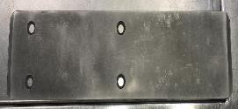  Figure 21. Design plate 1  Design Plate 1 | 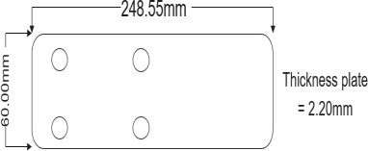  Figure 22. Dimension plate 1
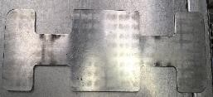  Figure 23. Design plate 2  Deisgn plate 2 | 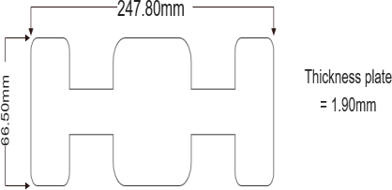  Figure 24. Dimension plate 2
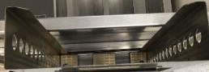  Figure 25. Design inner magazine  Design inner magazine | 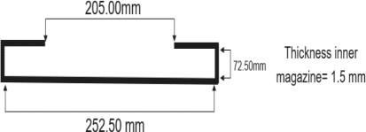  Figure 26. Dimension inner magazine

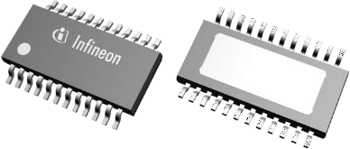

Test
Figure 20. Package TSDSO 24-32 [5]

To see the results of the pick arm lead frame drop, the first step of this test is to take the data first and after that make a histogram to see whether it matches the objective or target that we want or not.
How to collect data depends on the week we want, after that specify the date and select the error to view. And the data will be sorted as 7 weeks before and 7 weeks after being improved. Below there is the table is example for insert data collect before and after.

The table above has the dimensions of the part that was measured to see its interaction with the leadframe which has a length of 250mm x 70mm, which is where the plate does not cover all of the leadframe. The design of the inner magazine also has a 2mm gap which can make the leadframe move to the right or left so that the leadfrae is not neatly arranged. Bowing of the leadframe can occur because the leadframe moves right and left. it is necessary to measure the dimensions.
Interaction plate and LF
Before deciding on the design plate, it is necessary to create an interaction that will determine what the difference between the two object. The direction of the plate itself is fixed / not moving and the direction of the LF itself is fixed / not moving either.

- 2 interaction Plate 1-LF (mm)
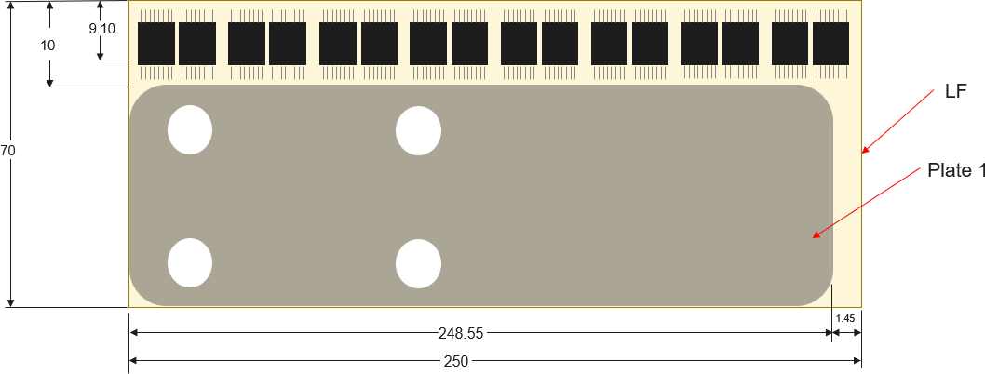

Out of plate

Out of plate
Figure 27. 2 interaction Plate 1-LF (mm)

During 2 interaction, at extreme case LF out of plate support, as much as 1.45 mm for width and 10 mm for length.

- 2 Interaction plate 2-LF (mm)
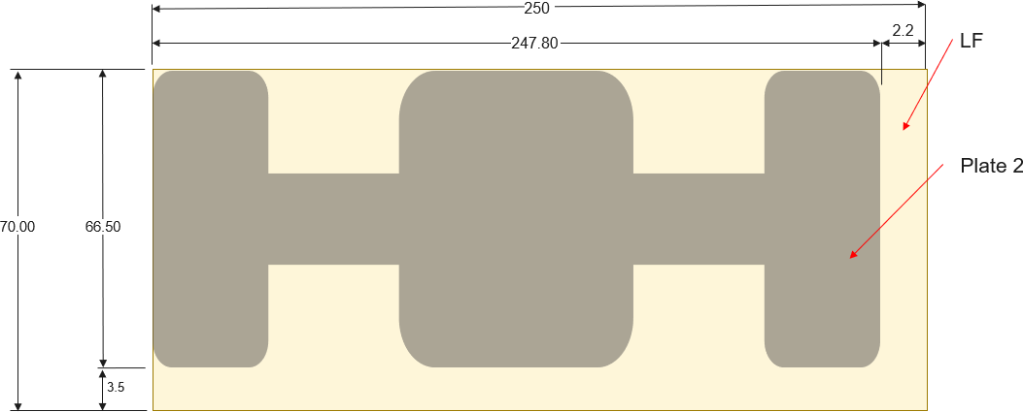

Out of plate support
Out of plate support
Figure 28. 2 Interaction plate 2-LF (mm)

During 2 interaction, at extreme case LF out of plate support, as much as 2.2 mm for width and 3.5 mm for length.

Interaction plate,magazine and LF
Before determining the design of the plate, it is necessary to create an interaction that will determine what the difference is between the three objects. The direction of the plate itself moves to the left, the direction of the LF also moves to the right. while the inner magazine does not move.
- 3 interaction Plate 1-LF-mag (mm)
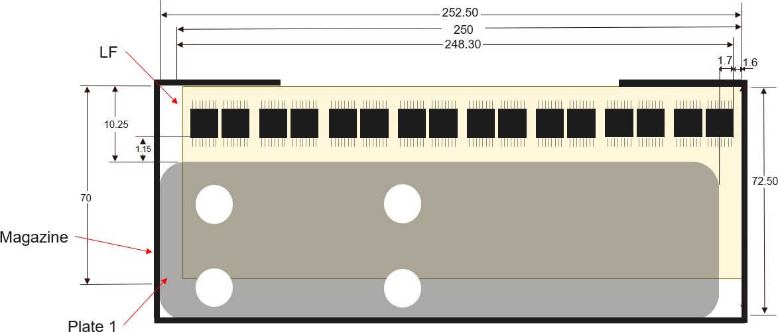
Out of plate suppor
Out of plate
Figure 29. 3 interaction Plate 1-LF-mag (mm)

During 3 interaction, at extreme case LF out of plate support, as much as 3.30 mm for width and 10.25 mm for length. (note: package out of plate as much as 1.7 mm and LF out of plate remain as much as 1.6 mm).
- 3 interaction Plate 2-LF-mag (mm)
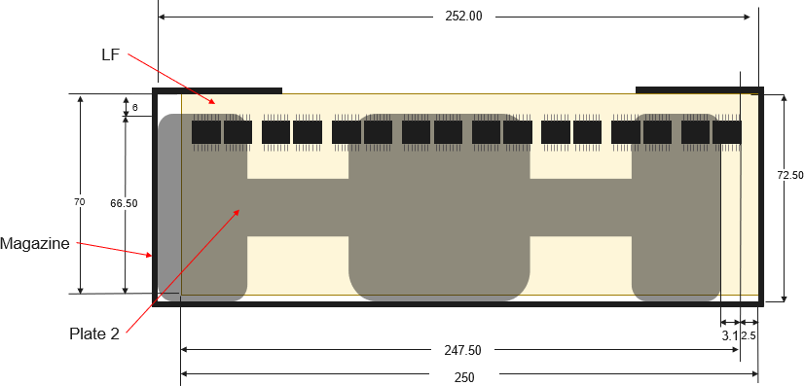
Out of plate
Out of plate
Figure 30. 3 interaction Plate 2-LF-mag (mm)

During 3 interaction, at extreme case LF out of plate support, as much as 6 mm for width and 5.6 mm for length. (note: package out of plate as much as 3.1 mm and LF out of plate remain as much as 2.5 mm).
Summary for interaction plate 1 and plate 2
The findings of this study are such that Plate 2 and Plate 1 present the most extreme results when they receive the highest out of the plate support areas. In other words, the ground of the current plates lacks the ability to properly keep the leadframe stable due to the footprint size. The high out of plate support value specifies that the current plate design may not be able to resist the loads or convey them in the right direction, which may inconvenience the whole operation and reduce the overall lifespan of the system.
This study shows that the resurrection of the plate with a bigger size start a new era in the design process Because the increase in plate size would, in turn, result in a larger support area that will make the whole leadframe to have the same amount of support that is more even and more efficient. This new design would of course have the advantage of lowering the out of plate support values thus will enable better stability of the whole system with less damage to leadframes.

Adjust elevator parameter
Elevators are vertical transportation devices capable of transporting loads such as people and goods by utilizing electric motors as the main source of propulsion. Elevators are used in several sectors such as agriculture, manufacturing, construction and so on. [7]
- Important parameter elevator

  - LF Elevator Drive In Distance Before LF Pick

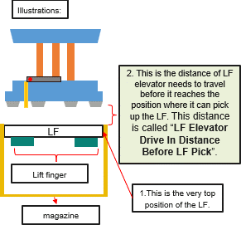

Figure 31. Illustartions parameter

  - LF Elevator Move Down Distance After LF Pick
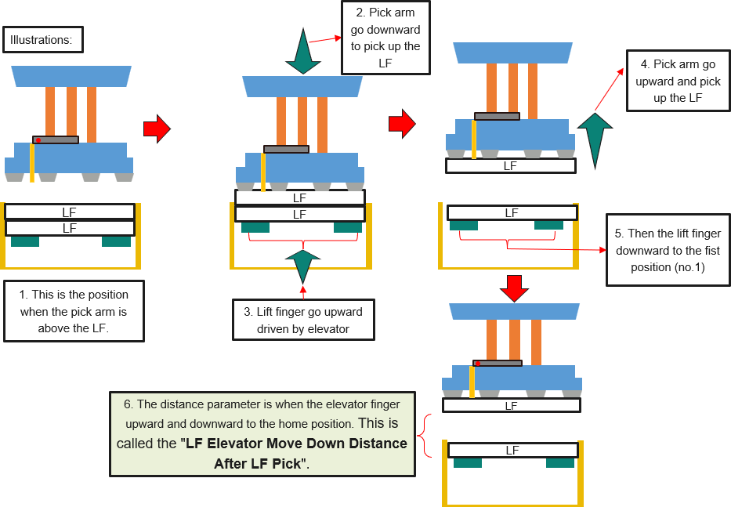
Figure 32. Illustrations parameter

These parameters are very important for setting the elevator on the dedam dejunk machine loader.
How lead frame bowing

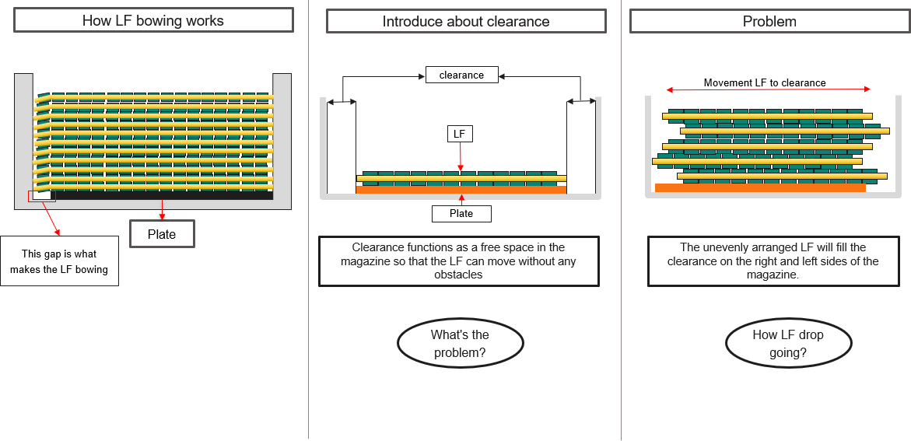
Figure 33. How lead frame bowing
This gap can cause the lead frame to bow. The bowing lead frame is created because the design plate is smaller than the design lead frame. The inner magazine design has a small amount of clearance which makes the lead frame not problematic to be raised up by the elevator. But this clearance makes the placement of the lead frame unstructured. And this is what affects the pick arm lead frame drop error.
How lead frame drop working

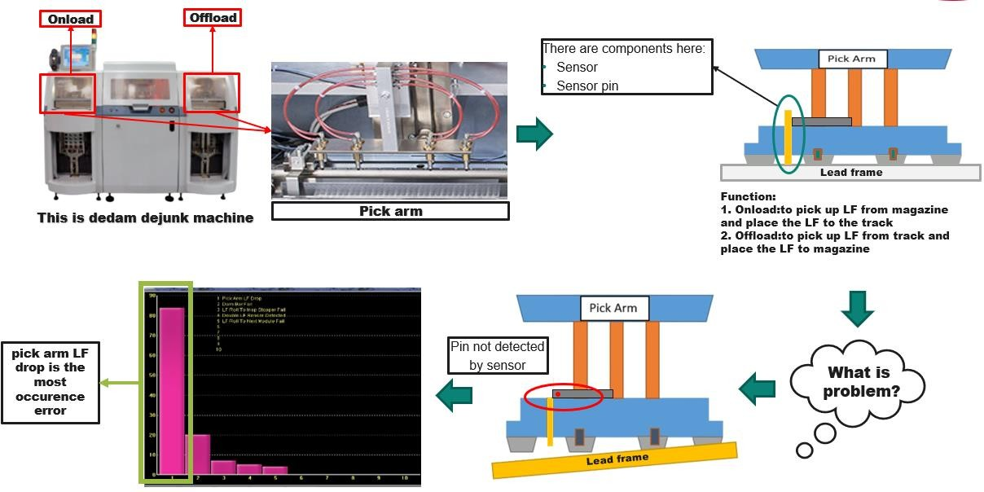
Figure 34. How lead frame drop working

In the dejunk dedam machine there are 3 parts, namely loader, process and unloader. In the loader and unloader there is a pick arm that can take lead frames. in the pick arm there are sensors and sensor pins that can detect the presence of lead frames.
The pick arm has its own function in each area. The loader pick arm functions as pick up LF from magazine and place the LF to the track and the unloader functions as pick up LF from track and place the LF to magazine.
The problem here is the pick arm on the loader which has many errors. When the pick arm picks up the lead frame to move it to the track, the leadframe does not reach the pick arm which makes the sensor pin cannot go up and makes the sensor cannot read the presence of the leadframe. Bowing lead frames can also affect the pick arm.
The machine will send an error message that serves as a marker or alarm that a pick arm lead frame drop error has occurred.
Design new plate

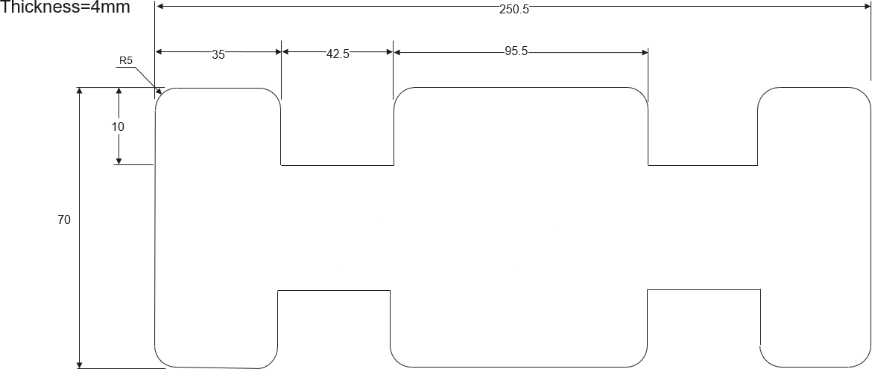
Figure 35. Design new plate (mm)

There are several reasons why this plate is designed in such a way, including covering all surfaces of the lead frame so that the leadframe does not shift or move out of the support plate.

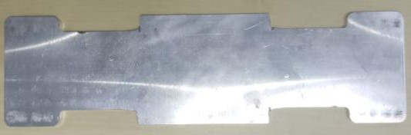
Figure 36. New plate

This plate is made based on the design as it should be. The plate will be tested to see if the plate is one of the factors that cause the leadframe to drop or nor.
1) 3 interaction plate, LF, and magazine
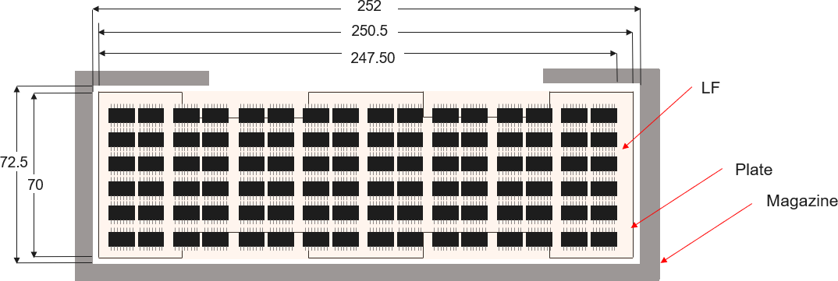
Figure 37. 3 interaction plate, LF, and magazine

This is an illustration of the 3 interactions that occur. the plate size is made larger than the lead frame in order to cover all units. When the lead frame goes right or left, the plate will still be able to support the lead frame so that the lead frame does not bow when on the pick arm. This will reduce the pick arm lead frame drop.
The interaction between the newest plate and leadframe designs has shown a significant advancement comparing with previous generations. These design adjustments reduce the gap between plate and leadframe, thereby, creating more accurate and stable joints. With a smaller gap, the components are more accurately integrated, which reduces the possibility of faults, and promotion of higher production efficiency.
This reduction of the gap is a key role in minimizing errors which often occur in the previous designs. By cutting down the distance that must be accommodated, the bonds among the components become stronger and more stable. This enables better performance and reduces the potential problems that may affect the end-product quality. The production efficiency is increased as the reduction of errors speeds up the checking and fixing processes.
On the whole, a new design with a smaller gap between plate and leadframe not only improves the quality of component interactions but it also cuts down the error rate. This leads to superior final products and more efficient production processes. This innovation manifests a significant progress in design technology, playing a notable role in the enhancement of reliability and consistency in the manufacturing industry.
Data collection
Data will be taken before and after the improvement, to see the comparison. Whether the improvement is successful or not, can be seen from some of the many data that have been reduced using the percent comparison formula.
- Data collection before
This data was taken before the improvement in the first 7 weeks.
Table 5. Data collection before

Number of weeks | Error Count
1 | 178
2 | 205
3 | 304
4 | 269
5 | 201
6 | 125
7 | 134
Total error | 1.416

This data was taken 7 weeks before the improvement. In week 3 this data is the highest of the other 7 weeks with 304 errors in 1 week, while the lowest occurrence was 125 in week 6.
- Data collection after
This data was taken after the improvement in the first 7 weeks.
Table 6. Data collection after
Number of weeks | Error Count
1 | 167
2 | 234
3 | 87
4 | 63
5 | 122
6 | 78
7 | 129
Total error | 880
This data was taken 7 weeks after the improvement. In week 2 this data is the highest of the other 7 weeks with 234 errors in 1 week, while the lowest occurrence was 63 in week 4.

- Summary of the data that has been taken
Table 7 has a very high number of errors before improvements are made. The high error on this machine will interfere with the effectiveness of the machine. The time required by the machine during the process is also longer than the normal period. Long time will hamper the process or performance of the machine. So from improvisation is needed. After making improvements to the plate, parameters, and maintaining the vacuum filter so that the pressure remains stable. The number in table 8 decreased, although not completely to 0. The lowest number was in week 4, which was 63 errors only. Compared to the lowest previous data that can
be seen from table 7 is week 6, which is 125 errors.
The comparison decreased due to improvisations made in the form of: parameter changes, design plate changes, and maintaining the vacuum filter so that the pressure remains stable. These changes were made to keep the machine effective,

so that the pick arm lad frame drop problem that exists in the dejunk dedam machine is reduced.

- Comparision data
Table 7. Comparision data
Pick arm LF drop error
before after
350
304
300
269
250
234
205
201
200 178
167
150
125134
122
129
100
87
63
78
50

0
W1 W2 W3 W4 W5 W6 W7 W1 W2 W3 W4 W5 W6 W7
Error
OCCURENCE

Based on the before and after improvement data, a percent comparison will be made to see the reduction. Percentage Comparison = (Difference / Initial Value) x 100
Percentage comparision = 536/1416 x 100 = 37,85%.
The table reveals that there was a decrease of 37.85%, which is a very significant coefficient from the initial value. This decrease is a result of certain technical issues, such as the size of the new plate being too small, making product production impractical. During this process, one has to set additional parameters to make adjustments efficient enough to fit the required design specifications as well. The changes affected the plant's performance in various ways, with the potential for lead frame drop on the dejunk dedusting machine reduced. The dejunk dedusting machine will be more effective than before.
The issue of the lead frame being the cause of the damage had to be carefully scrutinized and examined with the aim of guarding against future upgrades. In addition to the lead frame, other machine elements such as the vacuum filter, suction cup also need to be maintained in a proper manner to ensure that the entire circuit is working properly. In particular, this reduction is a consequence of not only design modifications but also parameter adjustments and regular servicing of machine components. All of these should be well considered and controlled as one of the factors that could lead to more pick arm lead frame drops than ever before.

  - CONCLUSION
To improve work efficiency and quality, a few suggestions need to be considered. First, increase the size of the bottom plate to ensure better stability and more even load distribution.
Secondly, refine existing parameters to improve accuracy and consistency of results, thereby reducing errors and increasing productivity. Nonetheless, ensure, lastly, that all personnel (men) are equally strict in following established procedures to maintain operational standards and avoid errors that could affect the final results. It is thus hoped that if these suggestions can be implemented, the overall performance and quality of work will improve.
The Reduce Pick Arm Lead Frame Drop initiative successfully achieved its objective of reducing errors by 37.85%. This significant reduction enhanced operational efficiency and minimized production costs associated with errors in pick arm handling. Moving forward, sustaining these improvements will be crucial through continuous monitoring and process optimization to ensure consistent performance and further operational enhancements.

  - REFERENCES

[1] Dickson Kho . [Online]. Available: https://teknikelektronika.com/pengertian-ic- integrated-circuit-aplikasi-fungsi-ic/ .
[2] [Online]. Available: https://ipqi.org/qc-seven-tools- tujuh-alat-pengendalian-kualitas/.
[3] F. Chusna, "Fishbone Diagram: Pengertian, Struktur, Proses dan Contohnya," 16 7 2022. [Online]. Available: https://magnate.id/fishbone- diagram/#:~:text=Fishbone%20diagram%20adalah
%20framework%20atau%20kerangka%20berpikir% 20yang,masalah%20dan%20solusinya%2C%20di% 20dunia%20bisnis%20dan%20pribadi..
[4] "Singulation, Trim & Form," ASMPT, [Online]. Available: https://semi.asmpt.com/en/products/icd/mp/. [Accessed 2023].
[5] Infineon, "Product," [Online]. Available: https://www.infineon.com/cms/en/product/.
[6] A. Setiawan, "Cara Mencari Perbandingan Persentase: Panduan Lengkap," 7 6 2024. [Online]. Available: https://versusbeda.com/cara-mencari- perbandingan-persentase-panduan- lengkap/#:~:text=Menghitung%20Perbandingan%2 0Persentase%20menggunakan%20Rumus%20Setela h%20mengetahui%20selisih,Persentase%20%3D%2 0%28Selisih%20%2F%20Nilai%20Awal%29%20x
%20100.
[7] Madenginer, "Apa Itu Elevator: Cara Kerja, Jenis Serta Kegunaannya," 13 3 2024. [Online]. Available: https://madenginer.com/elevator- adalah/#:~:text=Elevator%20adalah%20alat%20tran sportasi%20vertikal%20yang%20mampu%20menga ngkut,beberapa%20sektor%20seperti%20pertanian
%2C%20manufaktur%2C%20konstruksi%20dan%2 0sebagainya.

Attachment 1.Reasearch flowchart

\

- Fishbone diagram
- Pick arm area

  - Rubber Cup
  - Parameter Vacuum Pressure

  - Vacuum filter

  - Sensor Stuck or Not
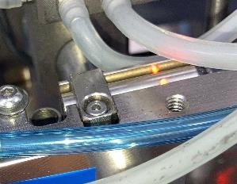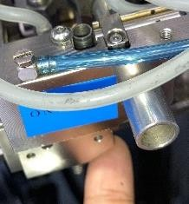

  - Parameter Magazine and LF

6.2 Interaction plate and LF

Out of plate support

Out of plate support



Out of plate

Out of plate

7.3 Interaction plate, LF, and magazine

Out of plate support

Out of plate support

Out of plate support

Out of plate support
- How LF Bowing work

- Illustration elevator

- Definition Pick arm lead frame drop

- Design New plate

- 3 Interaction Plate, LF, and magazine



